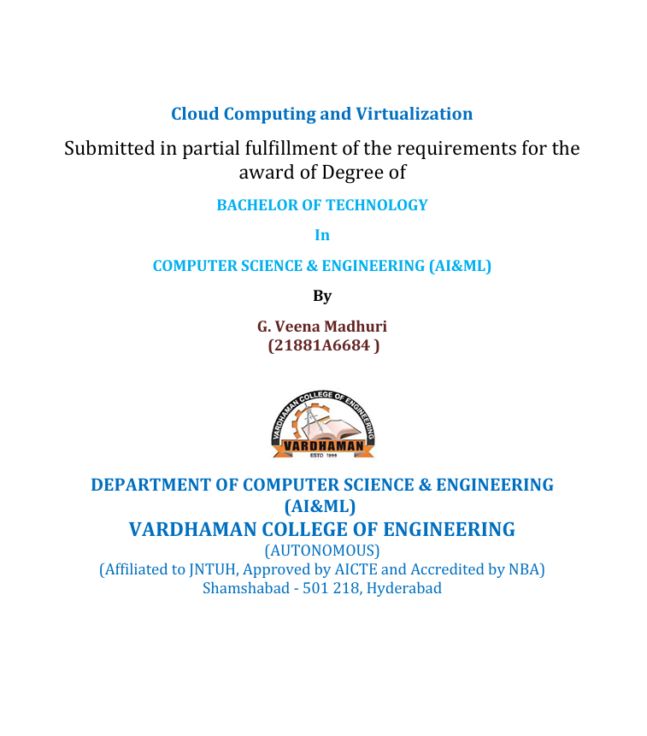

**ACKNOWLEDGEMENT**

The satisfaction that accompanies the successful completion of the task would be put incomplete without the mention of the people who made it possible, whose constant guidance and encouragement crown all the efforts with success.

We wish to express my deep sense of gratitude to **Dr. P. Pavankumar ,Associate Professor**

for their able guidance and useful suggestions, which helped us in completing the design part of potential project in time.

We are particularly thankful to **Dr. M. A. Jabbar**, Professor & Head, Department of Computer Science and Engineering (AI&ML) for his guidance, intense support and encouragement, which helped us to mould our project into a successful one.

We show gratitude to our honorable Principal **Dr. J. V. R. Ravindra**, for having provided all the facilities and support.

We avail this opportunity to express our deep sense of gratitude and heartful thanks to **Dr. Teegala Vijender Reddy**, Chairman and **Sri Teegala Upender Reddy**, Secretary of VCE, for providing congenial atmosphere to complete this project successfully.

We also thank all the staff members of the department of **CSE(AI&ML)** for their valuable support and generous advice. Finally, thanks to all our friends and family members for their continuous support and enthusiastic help.

**G. Veena Madhuri – 21881A6684**



**VARDHAMAN COLLEGE OF ENGINEERING**

(AUTONOMOUS)

(Affiliated to JNTUH, Approved by AICTE and Accredited by NAAC)

Shamshabad - 501 218, Hyderabad

DEPARTMENT OF COMPUTER SCIENCE & ENGINEERING

(AI&ML)

CERTIFICATE

Certified that this is the bonafide record of practical work done by Ms. G. Veena Madhuri, roll number 21881A6684 of B. Tech in the “CLOUD COMPUTING & VIRTUALIZATION” laboratory during the year 2024.

No. of Experiments done:

Total No. of Experiments:

Date: HOD Staff Member Incharge

Roll Number -21881A6684

Submitted for the practical exam held on:

**Index**

|  |  |  |  |  |  |
| --- | --- | --- | --- | --- | --- |
| **S.no** | **Date** | **Title** | **Pg.no** | **Marks** | **Sign** |
| 1 |  | Install Virtual box and making Ubuntu and Window Virtual Machine. |  |  |  |
| 2 |  | Create a Windows Virtual Machine in Microsoft Azure. |  |  |  |
| 3 |  | Create an Ubuntu Virtual Machine in Microsoft Azure. |  |  |  |
| 4 |  | Create a Virtual machine and do scale up in Azure. |  |  |  |
| 5 |  | Create a Virtual machine and do lock for VM in AZURE. |  |  |  |
| 6 |  | Create Ubuntu VM and run a python program in it. |  |  |  |
| 7 |  | Create a Ubuntu VM and transfer files using WinScp. |  |  |  |
| 8 |  | How to make Linux server as web server in AZURE. |  |  |  |
| 9 |  | Setup and configure AZURE web server for windows server (IIS). |  |  |  |
| 10 |  | How we are adding new users, login credentials, changing owner, create authorized key files. |  |  |  |
| 11 |  | Create a Windows VM and transfer files from desktop to remote desktop VM. |  |  |  |
| 12 |  | How to attach and detach data disks to Windows server in azure data center. |  |  |  |
| 13 |  | How to add data disks to linux server in azure data center. |  |  |  |
| 14 |  | Move Server Files from one Resource Group to another. |  |  |  |
| 15 |  | Create Azure Storage Account, Container – Upload and Delete Objects(blob) in it. |  |  |  |

**Q1. Install Virtual box and making Ubuntu and Window Virtual Machine.**

**Ubuntu:**

**Step-1**: Download VirtualBox for Windows and install it on your computer



<https://www.virtualbox.org/wiki/Downloads>

**Step-2**: Download the Ubuntu ISO file you want to install from the Ubuntu download page.



Note: The current version of Ubuntu only works on 64-bit machines.

**Step-3:** Open VirtualBox and select New in the top taskbar.



**Step-4:** Give your VM a name, choose Linux as the Type, then choose Ubuntu as the Version and select Next.



**Step-5:** Choose how much RAM you want to assign to the virtual machine and select Next. The recommended minimum is 1024 MB.



**Step-6:** Choose Create a virtual hard disk now and select Create.

**Step-7:** Choose VDI (VirtualBox Disk Image) and select Next.



**Note on (VDI):** Normally, Oracle VM VirtualBox uses its own container format for guest hard disks. This is called a Virtual Disk Image (VDI) file. This format is used when you create a new virtual machine with a new disk.

S**tep-8**: Choose Dynamically allocated or Fixed size for the storage type and select Next.



Tip: A fixed size disk performs better because the virtual machine doesn’t have to increase the file size as you install software.

**Step-9:**  Choose how much space you wish to set aside for Ubuntu and select Create.

**Note:**  The amount of space you allocate for your virtual machine determines how much room you must install applications, so set aside a sample amount.

**Step-10:** The name of your virtual machine will now appear on the left side of the VirtualBox manager. Select Start in the toolbar to launch your VM.



**Step-11:** This is the point where you need to choose the Ubuntu ISO file you downloaded earlier. If the VM doesn't automatically detect it, select the folder next to the Empty field.



**Step-12:** Select Add in the window that pops up.



**Step-13:** Choose your Ubuntu disk image and select Open.



**Step-14**: - Select Choose



**Step-15:** Select Start.



**Step-16:**  Your VM will now boot into a live version of Ubuntu. Choose your language and

select Install Ubuntu

u. 

**Step-17:** Choose your keyboard layout and select Continue.



**Step-18:** Choose Normal installation or Minimal installation, then select Continue.

**Step-19:** Choose Erase disk and install Ubuntu and select Install Now, then select Continue to ignore the warning.

Note: This step will not erase your computer’s physical hard drive; it only applies to the virtual machine.



**Step-20**: - Choose your time zone on the map, then select Continue.

**Step-21**: - Set up your user account and select Continue.

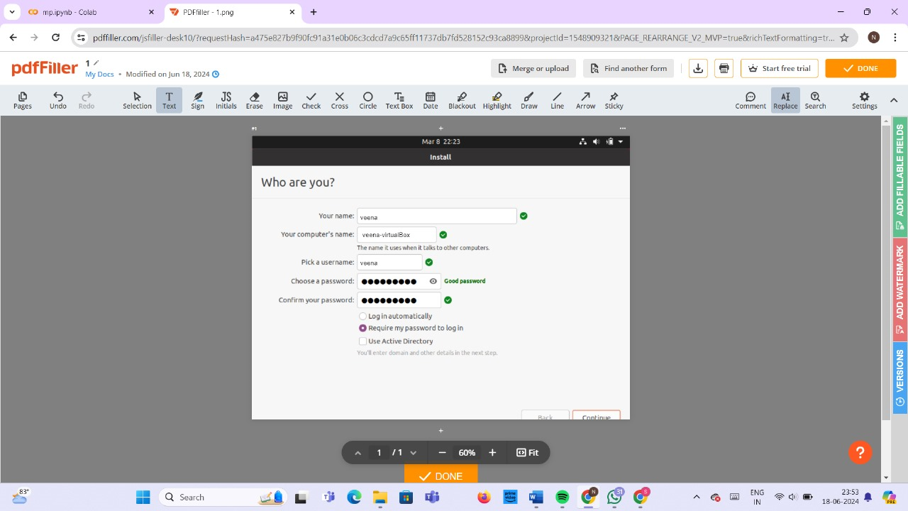

**Step-22**: - Select Restart Now.



**Step-23**: - After restarting your VM and booting into Ubuntu, you may notice that the desktop doesn’t scale correctly if you choose to view it in full-screen mode. You can fix this problem by selecting the VBox_Gas icon to install VirtualBox Guest Additions.

**Output:**



**Windows:**

Similarly, Follow the same steps above to Build Windows Virtual Machine.

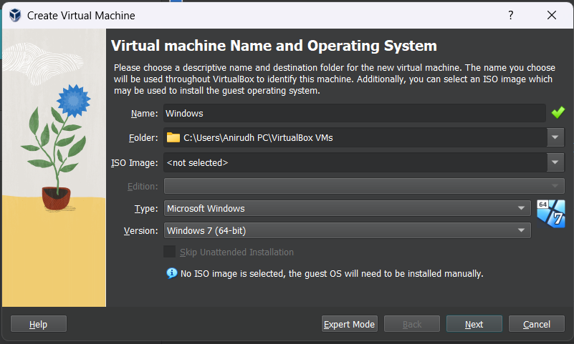

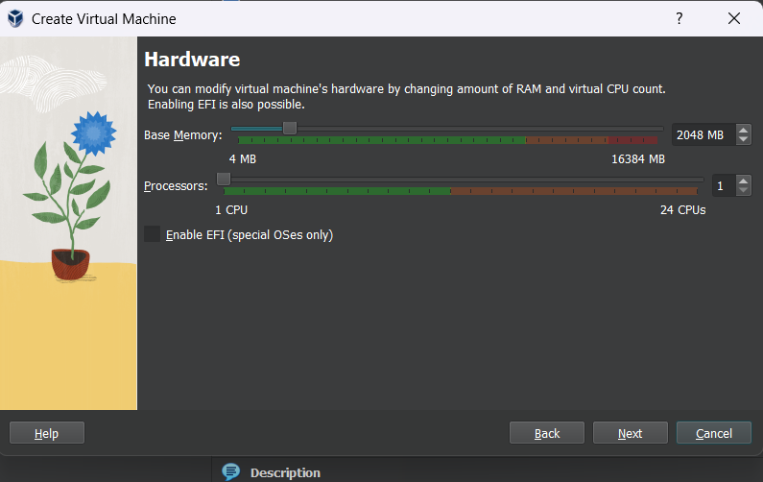

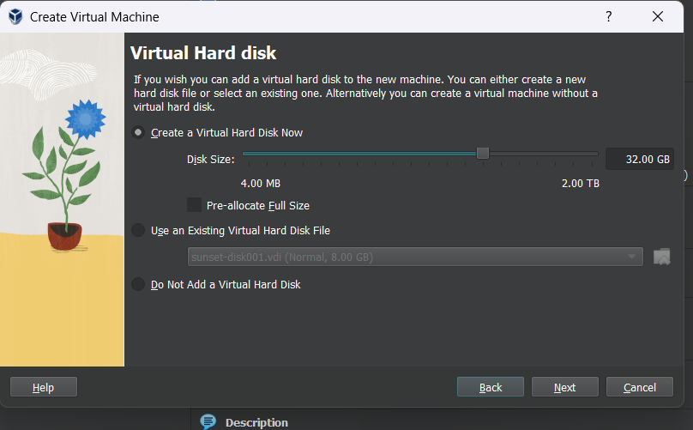

**Output:**

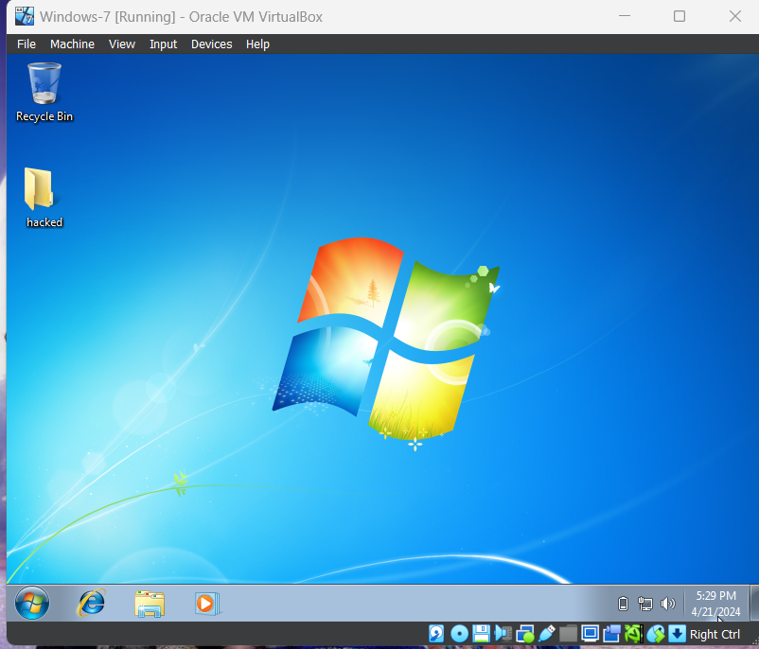

**Q2) Create a Windows Virtual Machine in Microsoft Azure**

**Step-1:** Sign in to your Microsoft Azure account.

**Step-2:** Go To Virtual machine, and click on “Create” to create a window virtual machine.

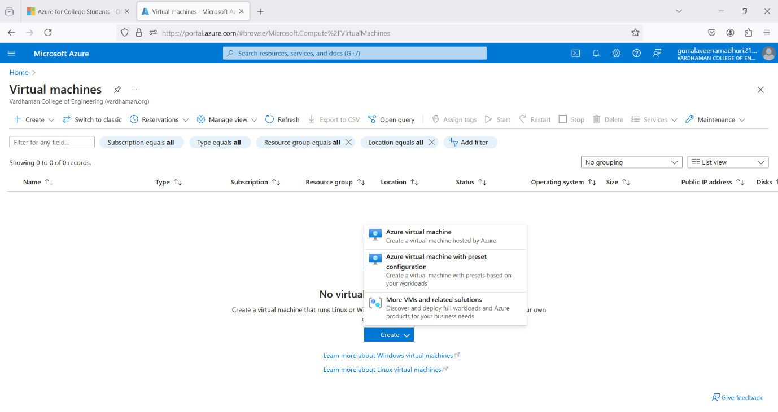

**Step-3:** Fill the details in that window by creating a “Resource Group”, Zone: Asia, Image: window, Select the disk storage and so on. After that click on “Create + Review”. And Finally click on “Create”

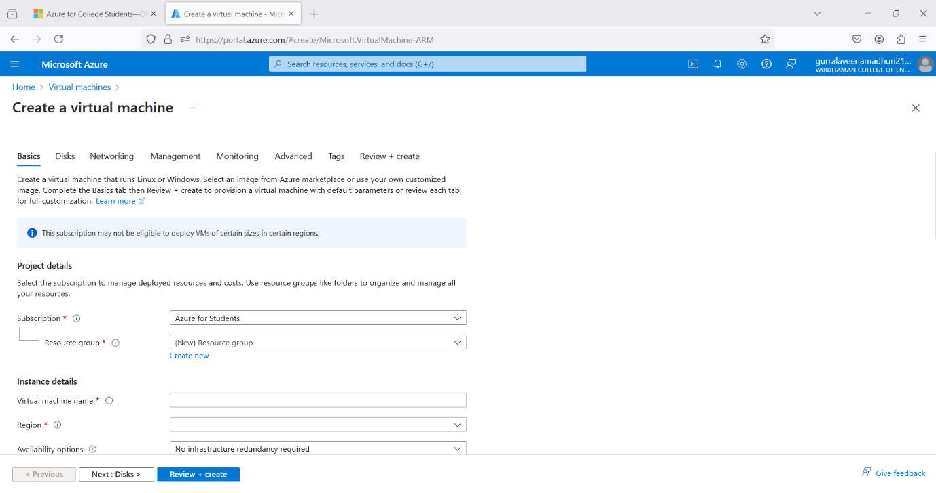

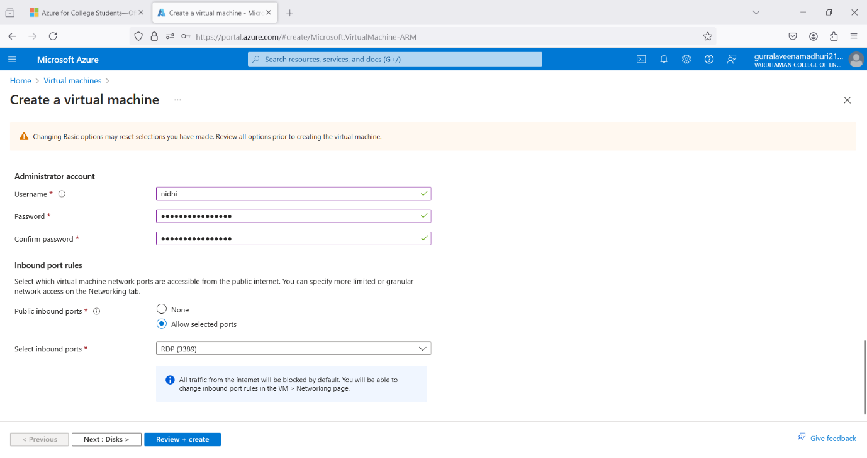

**Step-4:** After Deployment is over, Go to the remote desktop connection.

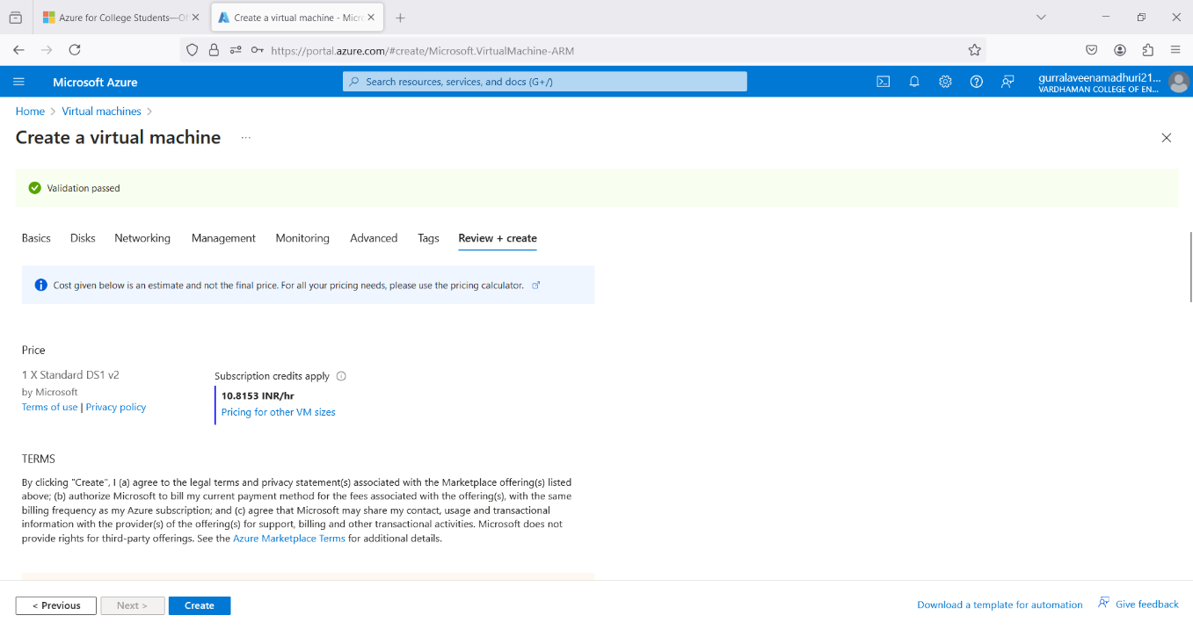

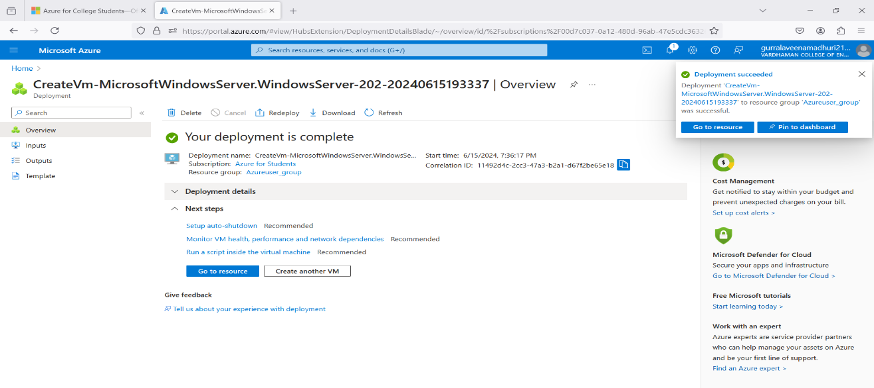

**Step-5:** Firstly, copy the public IP Address of that created virtual machine.

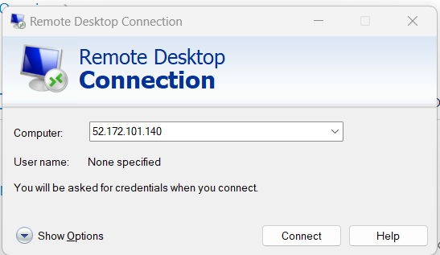

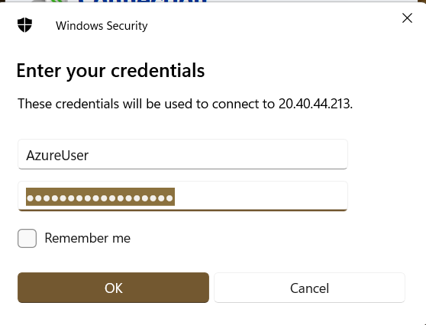

**Step-6:** By using that copied IP Address open the window virtual machine through remote desktop connection.

**Output:**

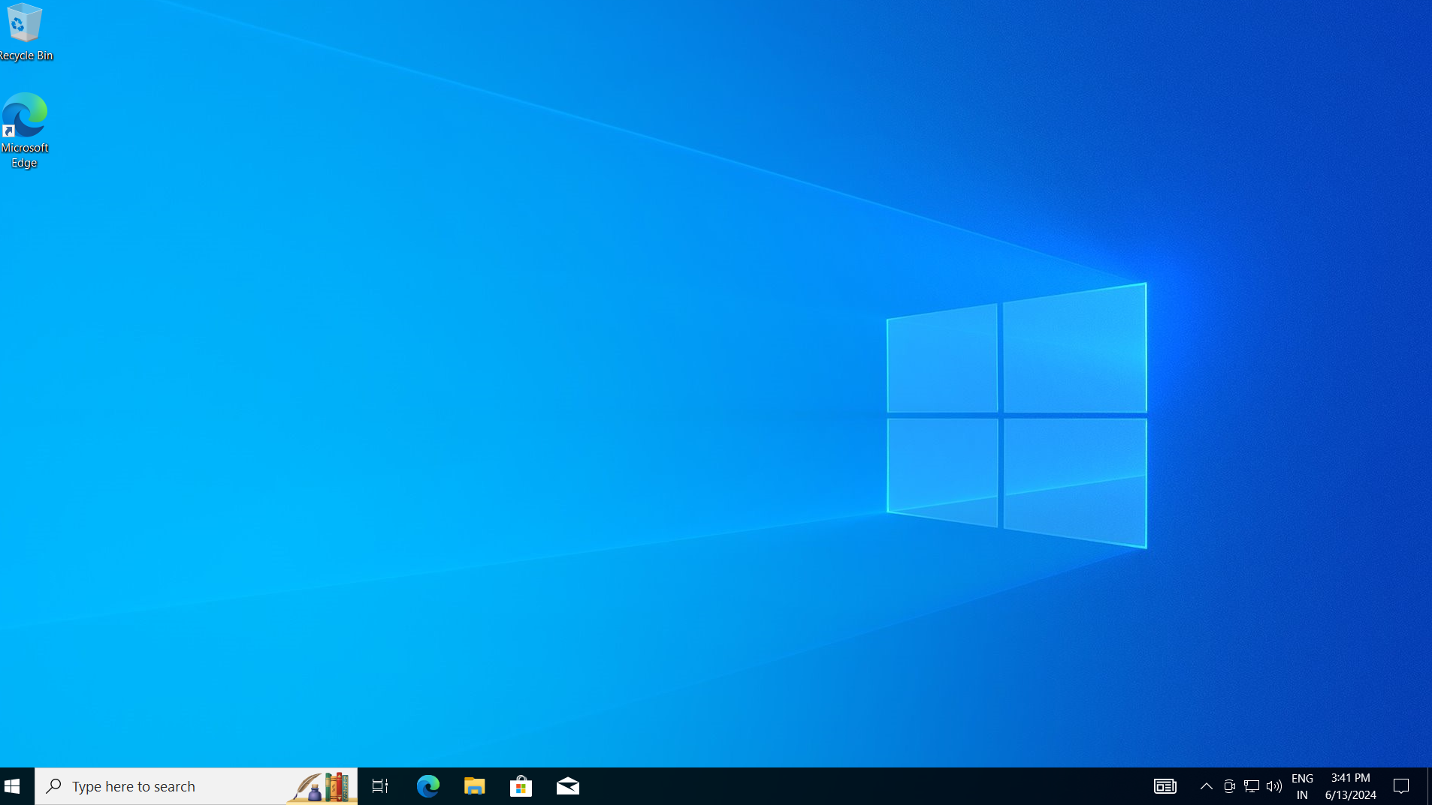

**Q3) Create an Ubuntu Virtual Machine in Microsoft Azure**

**Step-1:** Sign in to your Microsoft Azure account.

**Step-2:** Go To Virtual machine, and click on “Create” to create a window virtual machine.

****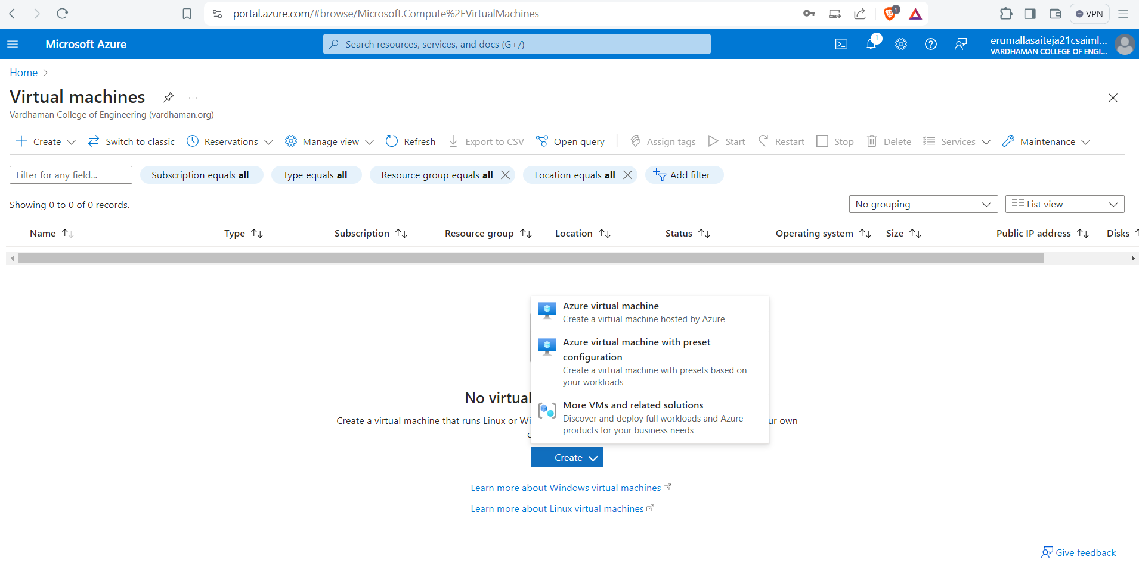

**Step-3:** Fill the details in that ubuntu by creating a “Resource Group”, Zone: Asia, Image: ubuntu, select “SSH”, Select the disk storage and so on. After that click on “Create + Review”. And finally click on “Create”.

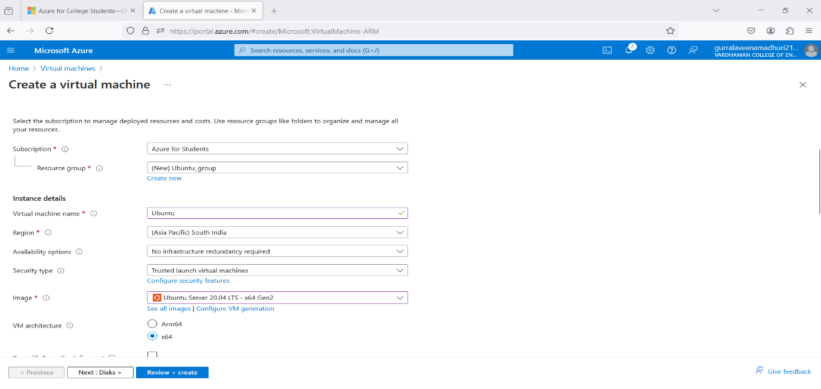

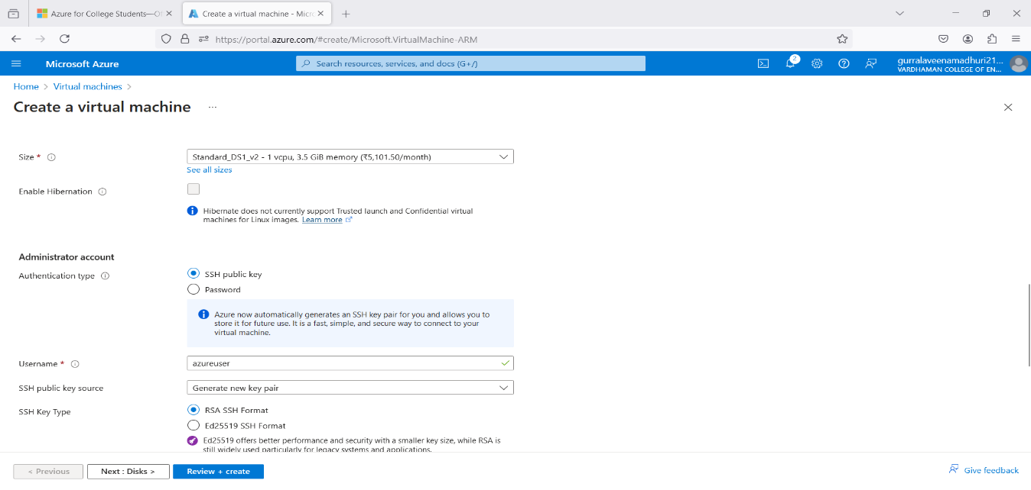

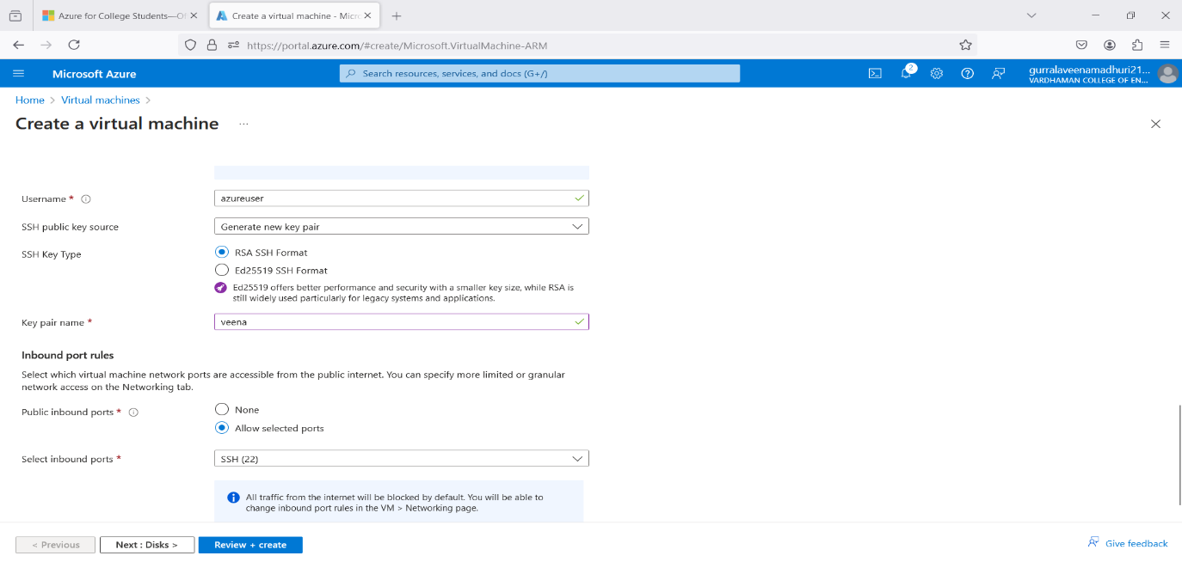

**Step-4:** After Deployment is over, Go to the remote desktop connection.

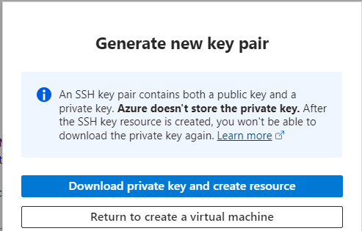

**Step-5:** Firstly, copy the public IP Address of that created virtual machine.

**Step-6:** Go to putty gen and click on load the key generator that you have downloaded.

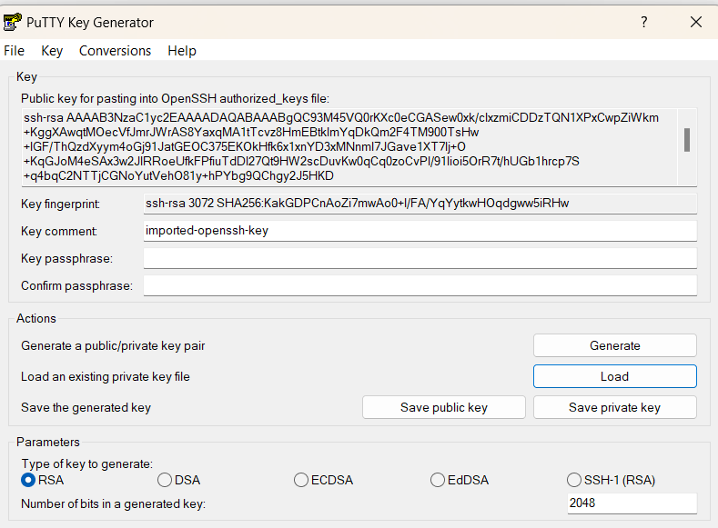

**Step-7:** In putty, put the Copied IP Adress into it, and then go to ssh->auth->credentials and the put the generated private key.

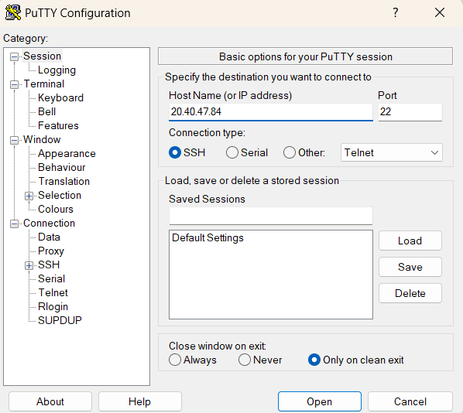

**Step-8:** A login page will be opened in that type your username and you will be into the ubuntu.

**Output:**

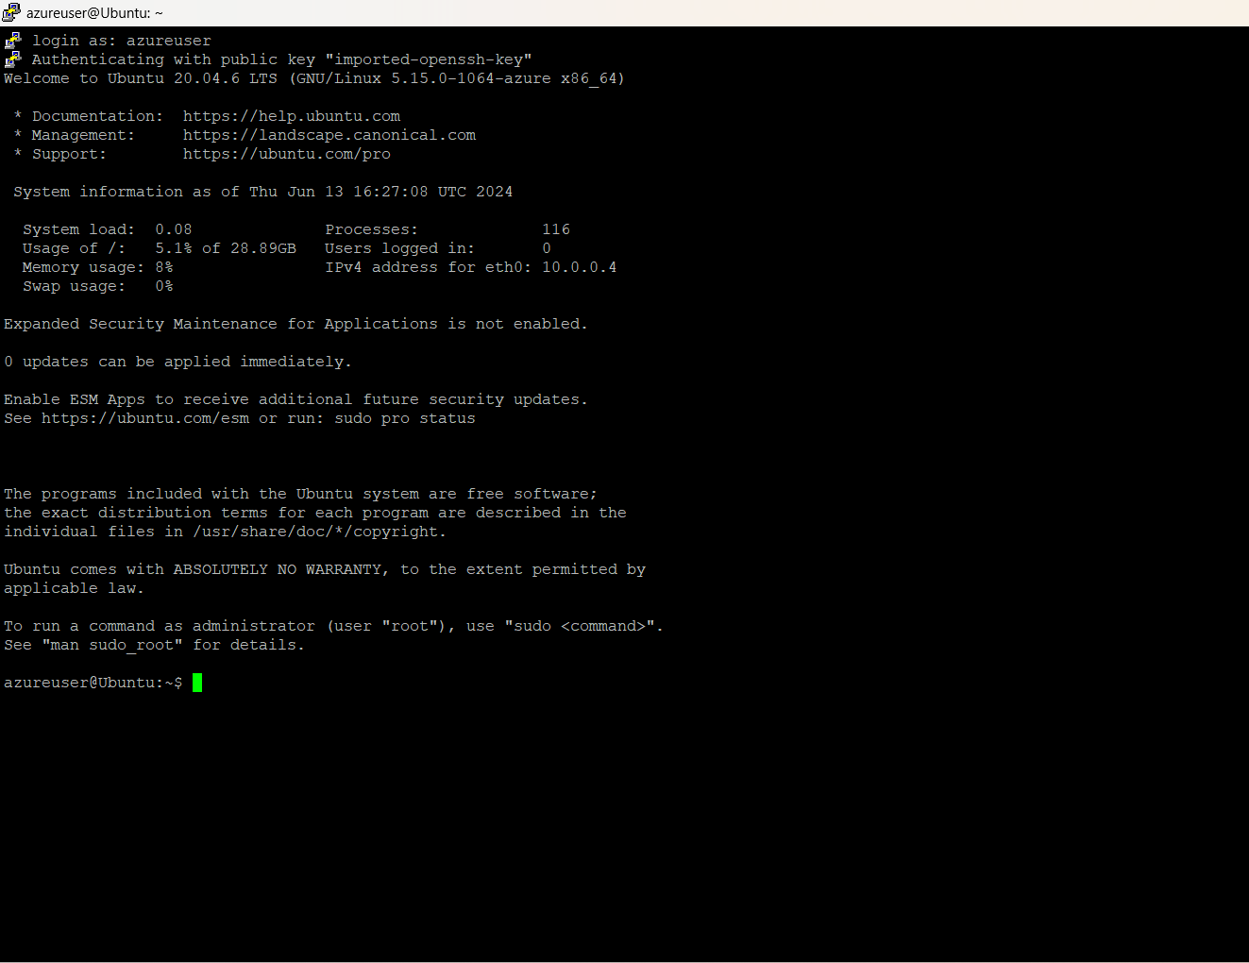

**Q4) Create a Virtual machine and do scale up in Azure.**

**Step-1:** Create a virtual machine (ubuntu or windows).

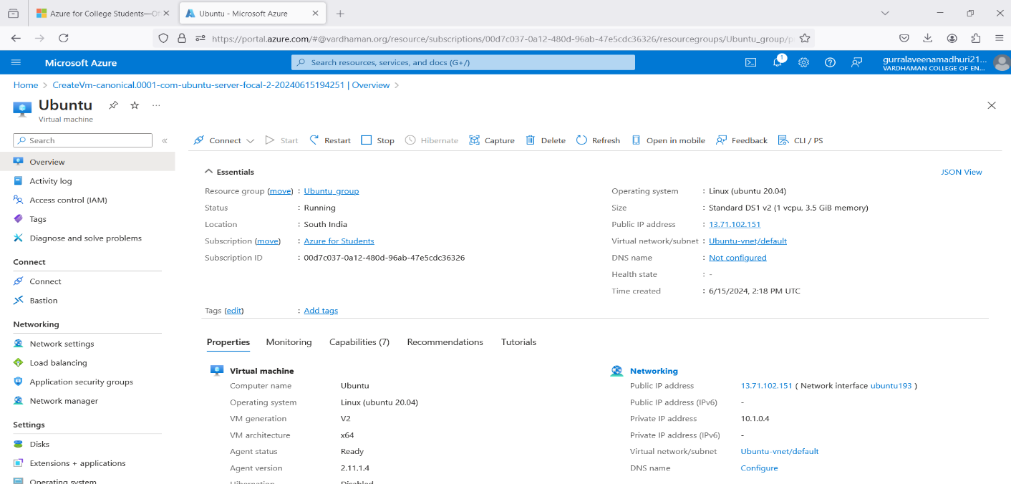

**Step-2:** After deployment of VM stop VM for scaling**.**

**Step-3:** On the left side there will be settings and click on disks.

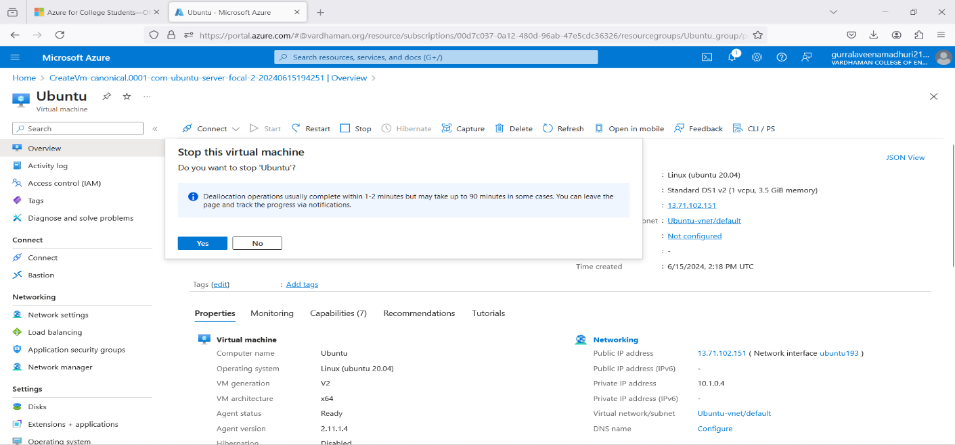

**Step-4:** click on disk name and select your preferred size, save it.

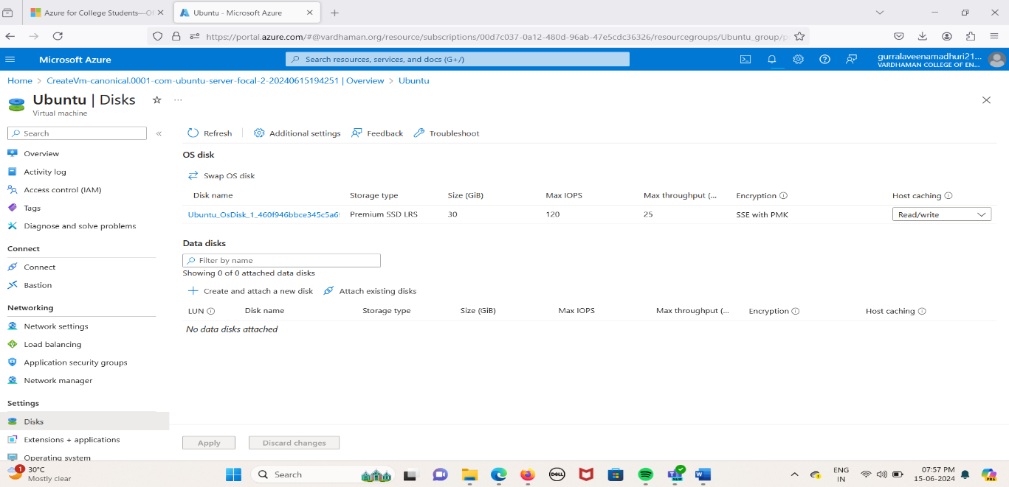

**Step-5:** On the left side there will be select + performance and click on size.

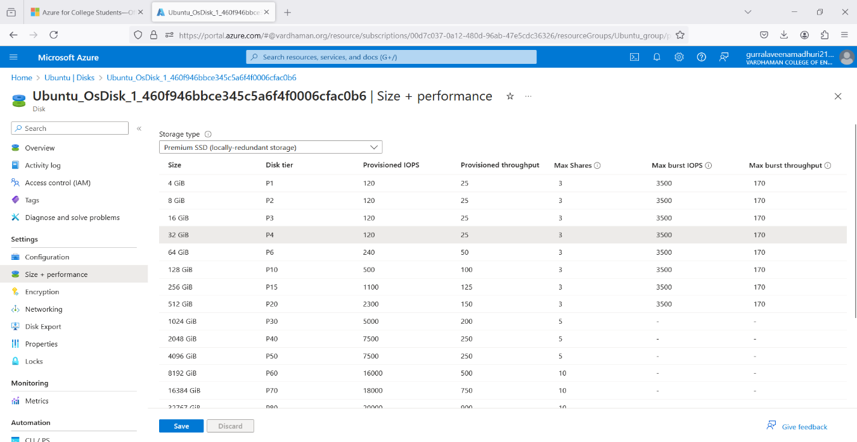

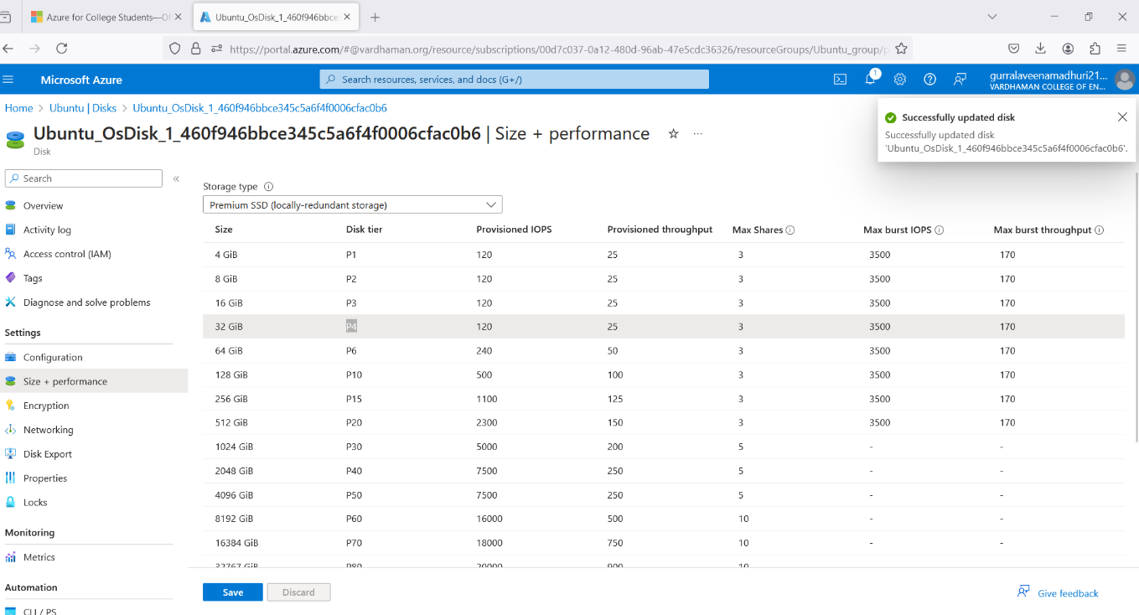**Step-6:** click on disk name and select your preferred ram size, save it.

**Q5) Create a Virtual machine and do lock for VM in AZURE.**

**Step-1:** Create a virtual machine (ubuntu or windows).

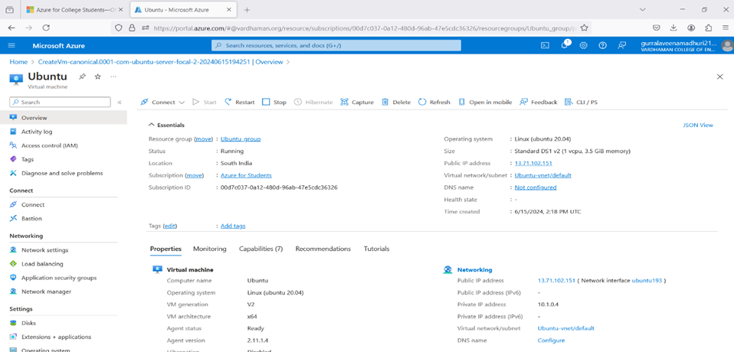

**Step-2:** On the left side there will be settings and click on locks, give lock name and select lock type.

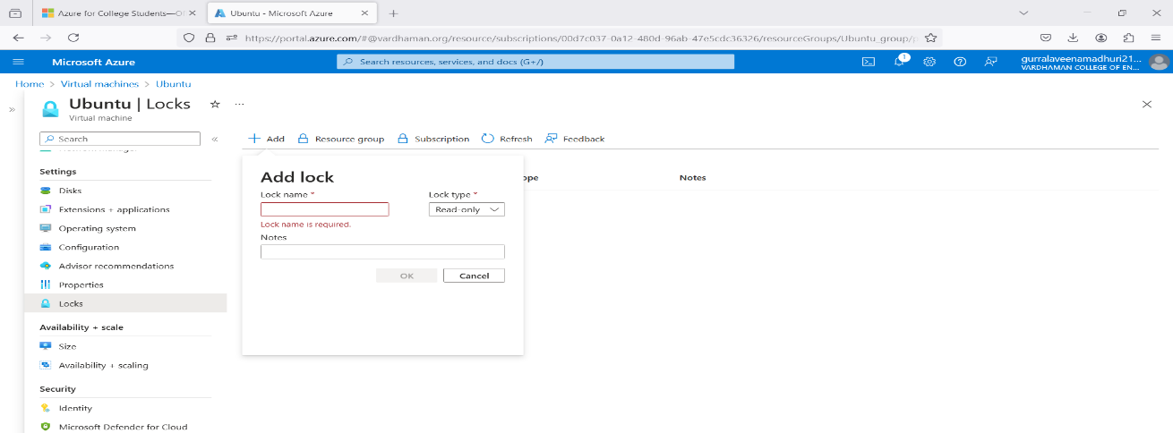

**Step-3: click on ok.**

Similarly, you can do for Resource group and subscriptions.

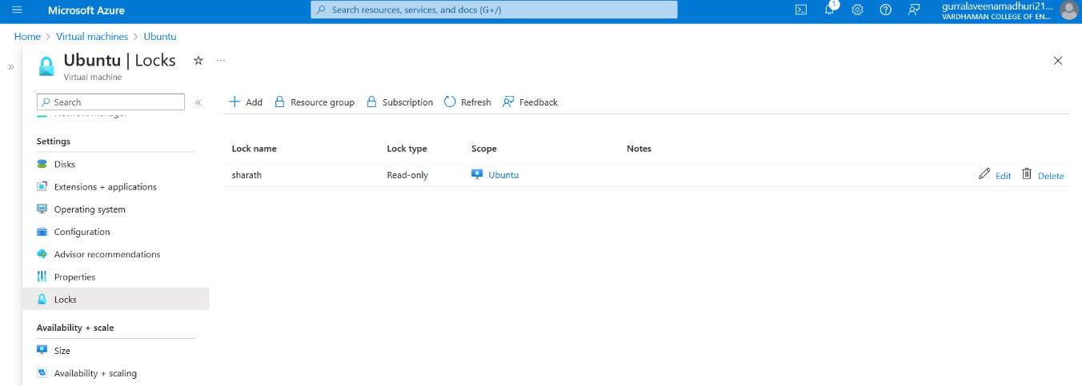

Note: After creating the lock, you need to delete it for deleting VM.

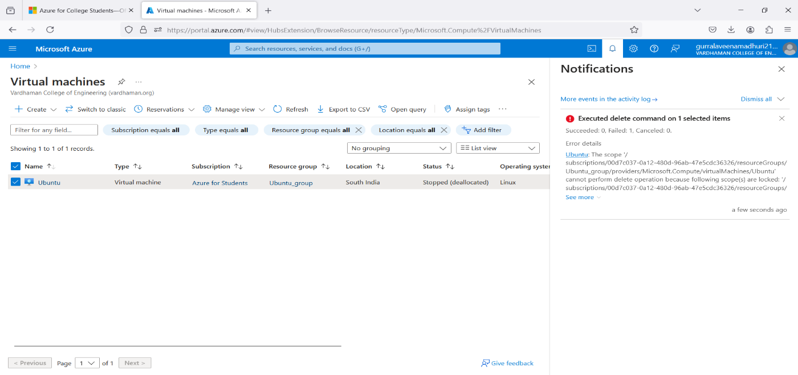

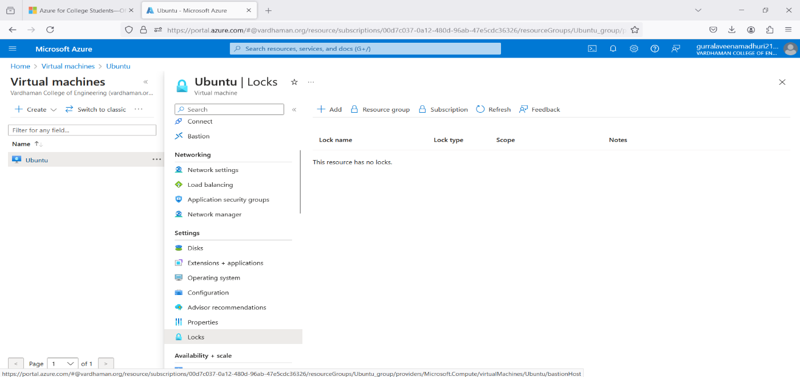

**Q6) Create Ubuntu VM and run a python program in it.**

**Step-1:** Sign in to your Microsoft Azure account.

**Step-2:** Go To Virtual machine, and click on “Create” to create a window virtual machine.



**Step-3:** Fill the details in that ubuntu by creating a “Resource Group”, Zone: Asia, Image: ubuntu, select “SSH”, Select the disk storage and so on. After that click on “Create + Review”. And finally click on “Create”.

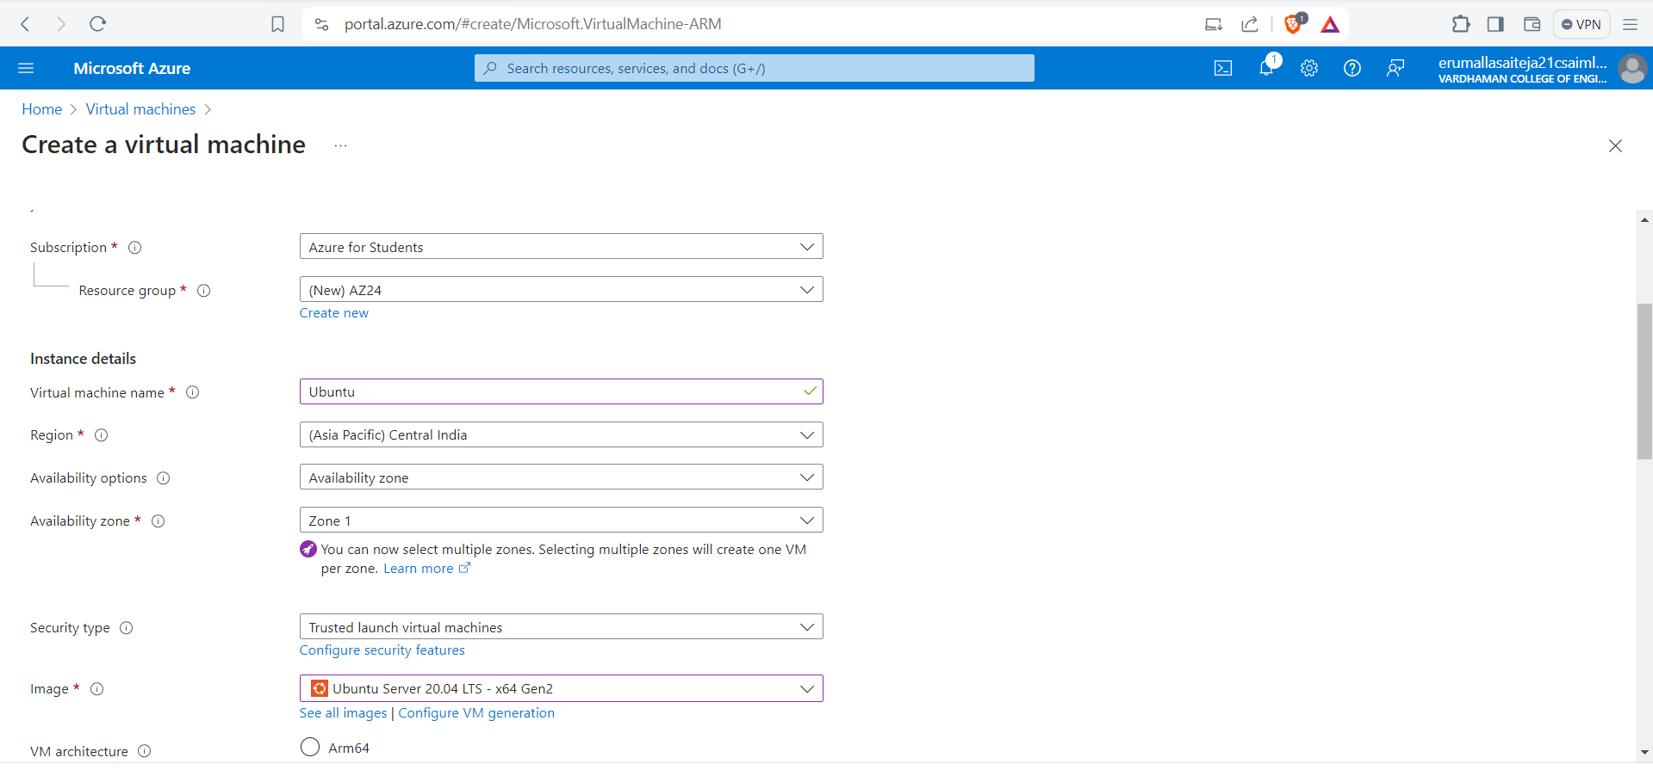

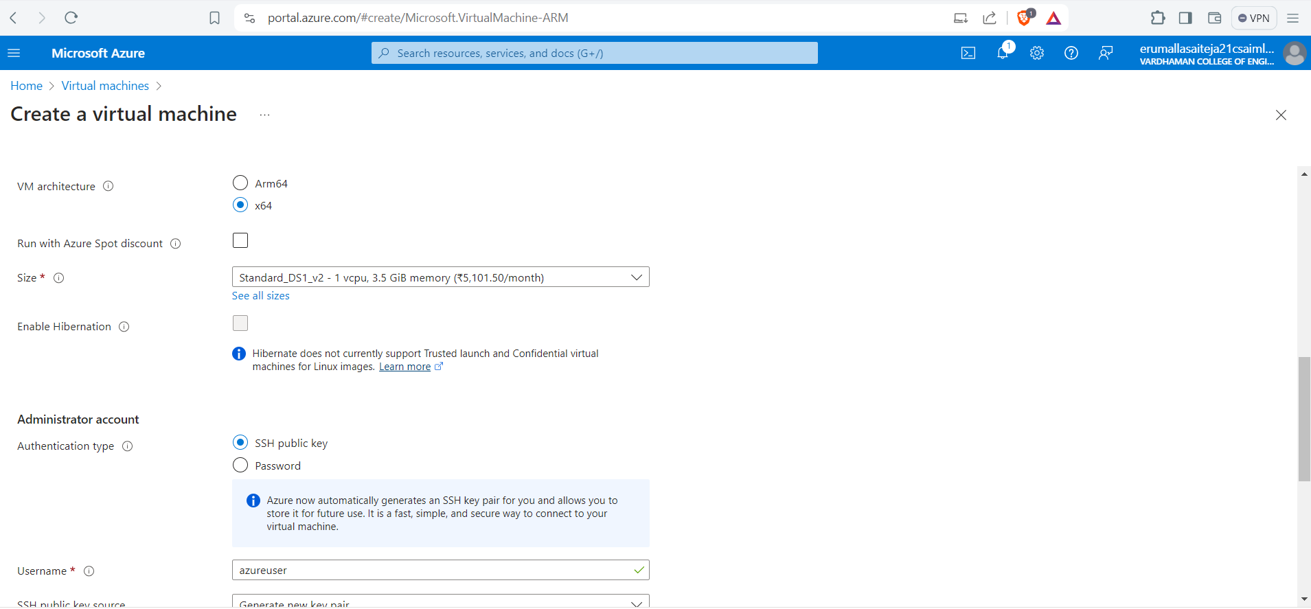

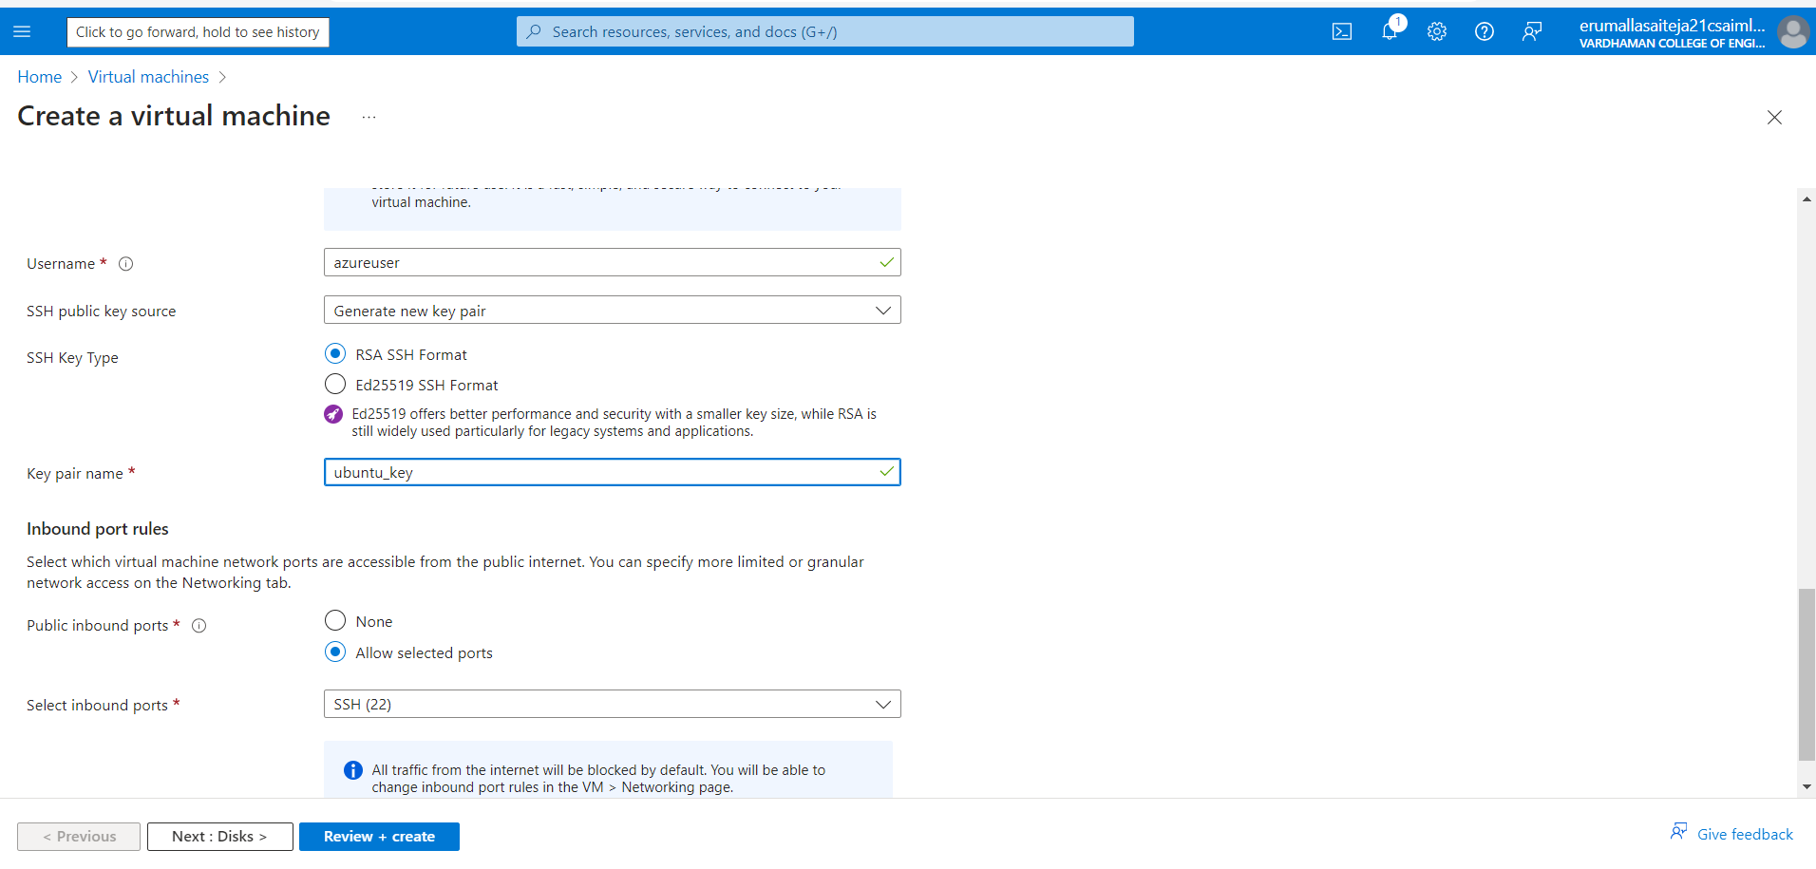

**Step-4:** After Deployment is over, Go to the remote desktop connection.



**Step-5:** Firstly, copy the public IP Address of that created virtual machine.

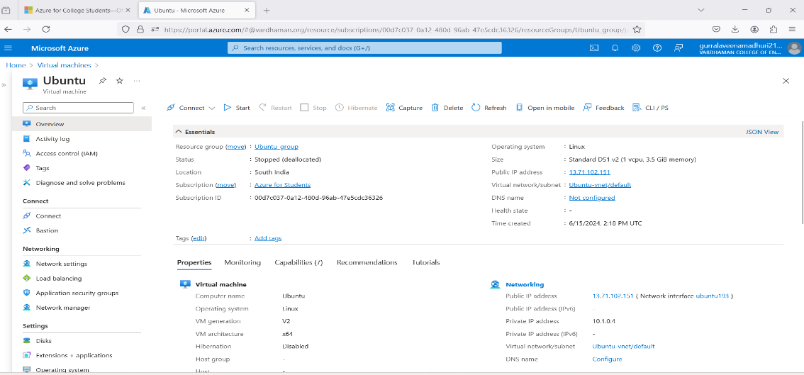

**Step-6:** Go to putty gen and click on load the key generator that you have downloaded.



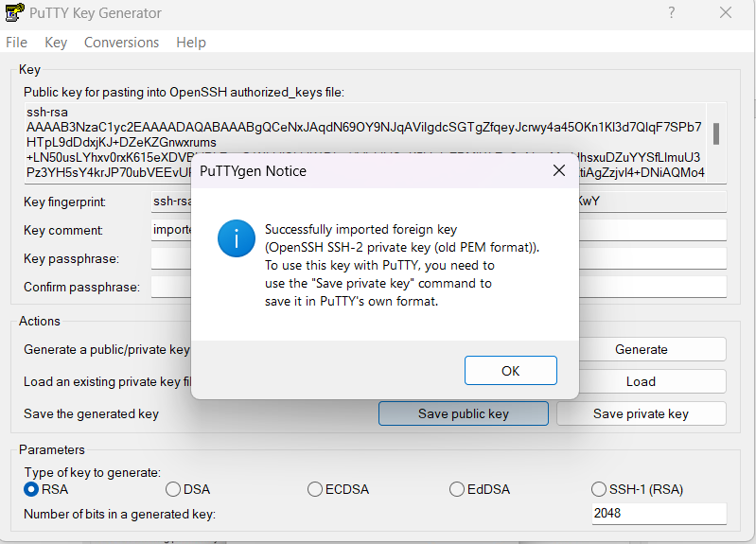

**Step-7:** In putty, put the Copied IP Adress into it, and then go to ssh->auth->credentials and the put the generated private key.



**Step-8:** A login page will be opened in that type your username and you will be into the ubuntu.

**Step-9:** Login with your username and type python3, write your python program and execute it.



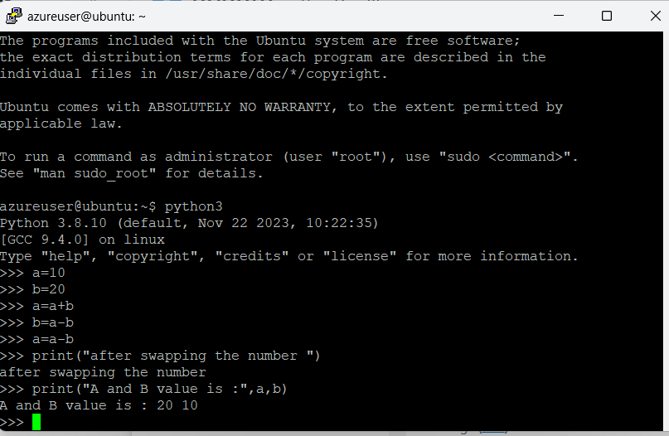

**Q7) Create a Ubuntu VM and transfer files using WinScp.**

**Step-1:** Sign in to your Microsoft Azure account.

**Step-2:** Go To Virtual machine, and click on “Create” to create a window virtual machine.



**Step-3:** Fill the details in that ubuntu by creating a “Resource Group”, Zone: Asia, Image: ubuntu, select “SSH”, Select the disk storage and so on. After that click on “Create + Review”. And finally click on “Create”.







**Step-4:** After Deployment is over, Go to the remote desktop connection.



**Step-5:** Firstly, copy the public IP Address of that created virtual machine.

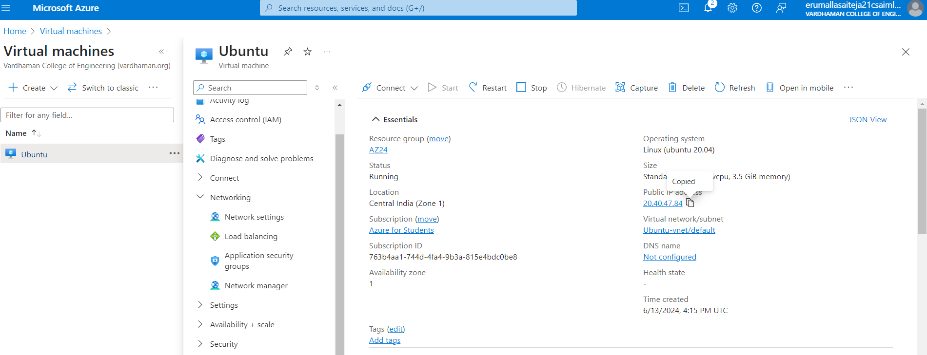

**Step-6:** Go to putty gen and click on load the key generator that you have downloaded.





**Step-7:** In putty, put the Copied IP Adress into it, and then go to ssh->auth->credentials and the put the generated private key.



**Step-8:** A login page will be opened in that type your username and you will be into the ubuntu.

**Step-9:** Login into your ubuntu VM using PUTTY and type ls command as you can see nothing.



**Step-10:** Open WinScp at right bottom you can see Advanced option->SSH->Authentication->In that drag private key file and click on ok.

At last Login into your account using public IP address and username in WinScp.

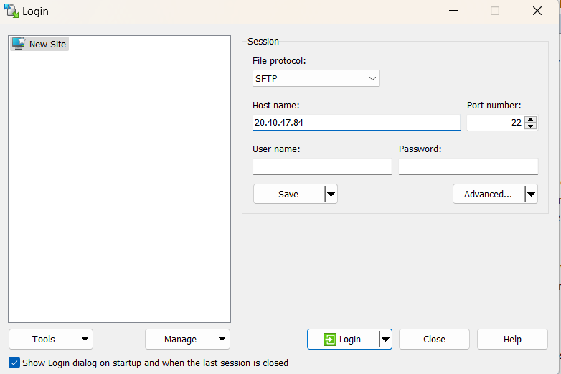

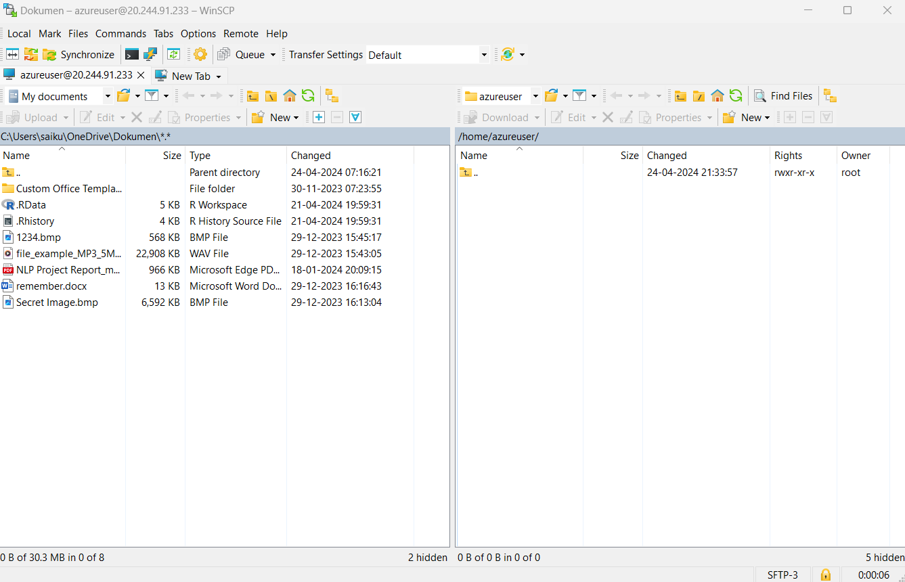

Now, you can drag your files from your desktop to ubuntu VM in WinScp.

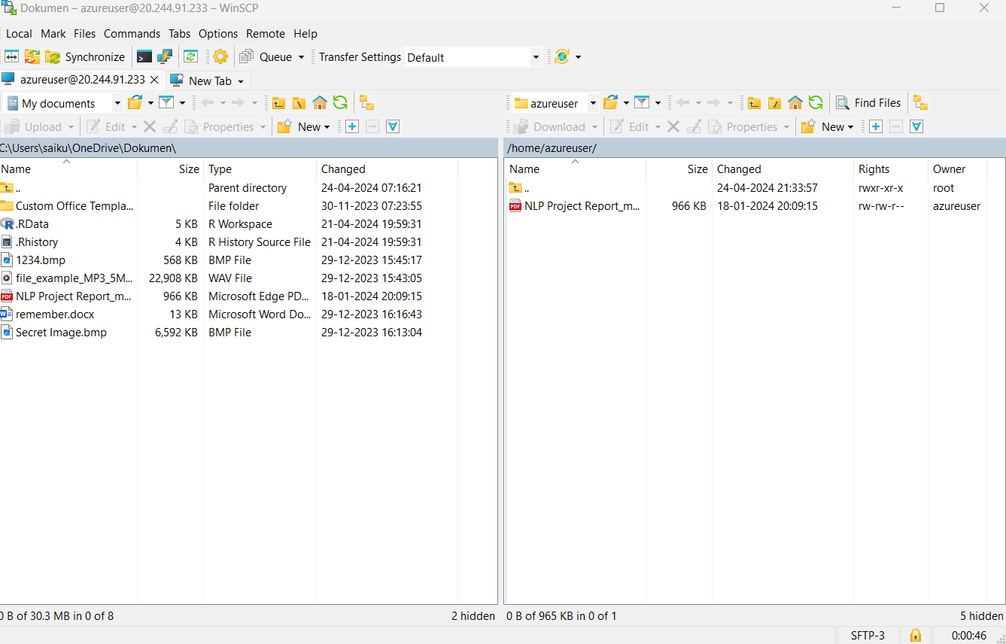

**Step-11:** Now again type ls command as you can see file inside ubuntu VM.

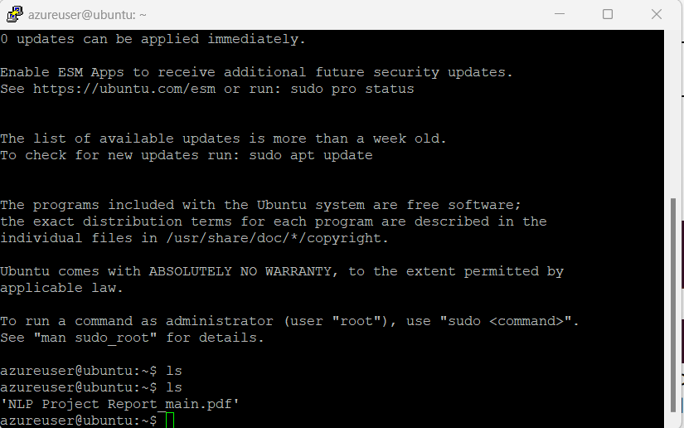

**Q8) How to make Linux server as web server in AZURE.**

**Step-1:** Sign in to your Microsoft Azure account.

**Step-2:** Go To Virtual machine, and click on “Create” to create a window virtual machine.

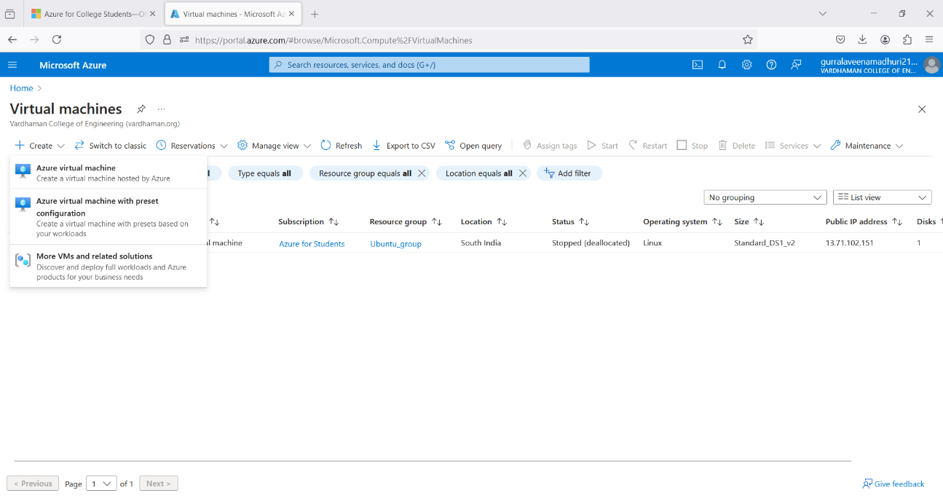

**Step-3:** Fill the details in that ubuntu by creating a “Resource Group”, Zone: Asia, Image: ubuntu, select “SSH”, Select the disk storage and so on. After that click on “Create + Review”. And finally click on “Create”.







**Step-4:** After Deployment is over, Go to the remote desktop connection.



**Step-5:** Firstly, copy the public IP Address of that created virtual machine.

**Step-6:** Go to putty gen and click on load the key generator that you have downloaded.



**Step-7:** In putty, put the Copied IP Adress into it, and then go to ssh->auth->credentials and the put the generated private key.

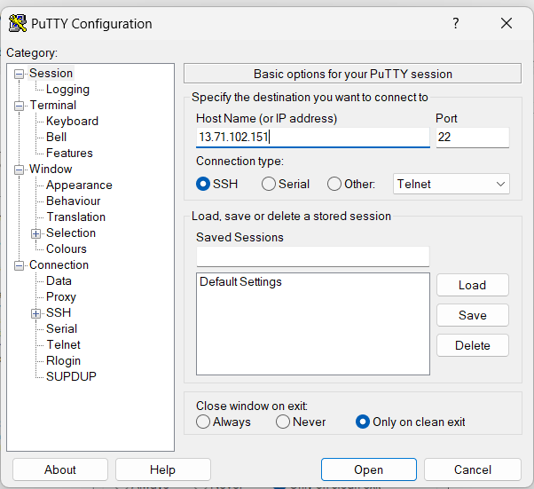

**Step-8:** A login page will be opened in that type your username and you will be into the ubuntu.

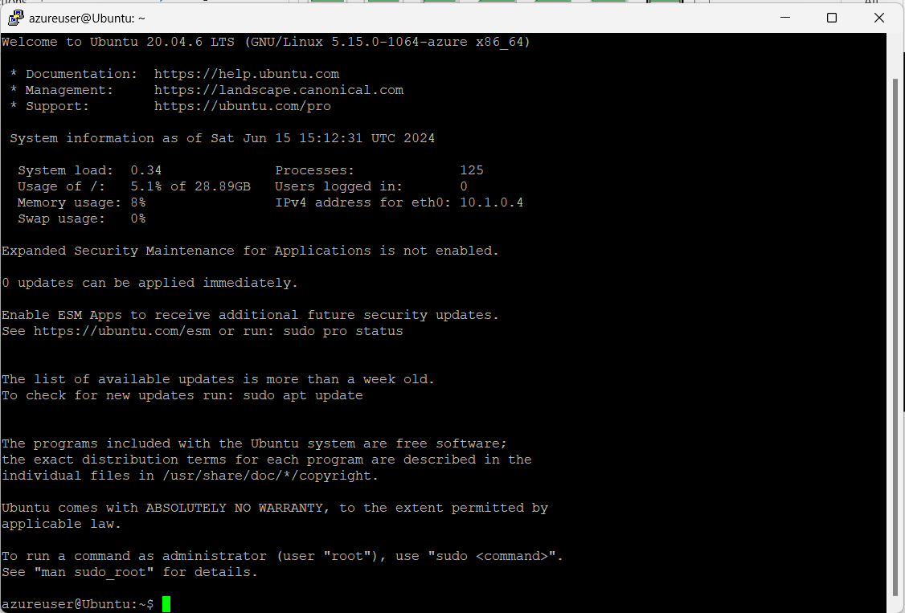

**Step-9:** Login into your Ubuntu VM using your username and type the following commands.  
$sudo su

$sudo apt-get update

After typing the two commands, now install web server using the below command

$sudo apt-get install nginx

After installing in VM, paste the public ip address in desktop browser and you can see.

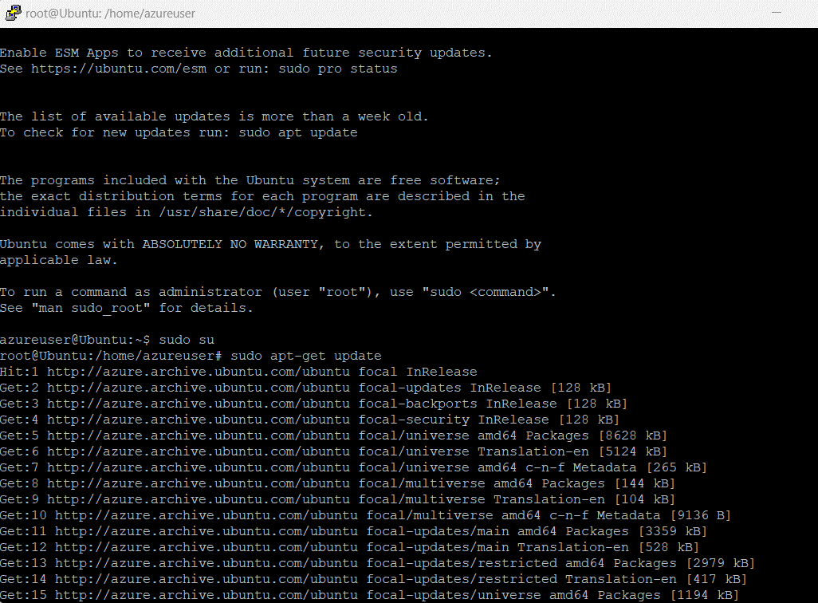

**Step-10:** To remove following information and keep new information in that page type the following command and refresh the browser page.

$cd /var/www/html

$rm index.nginx-debian.html

$echo “Welcome to CSM “>index.html

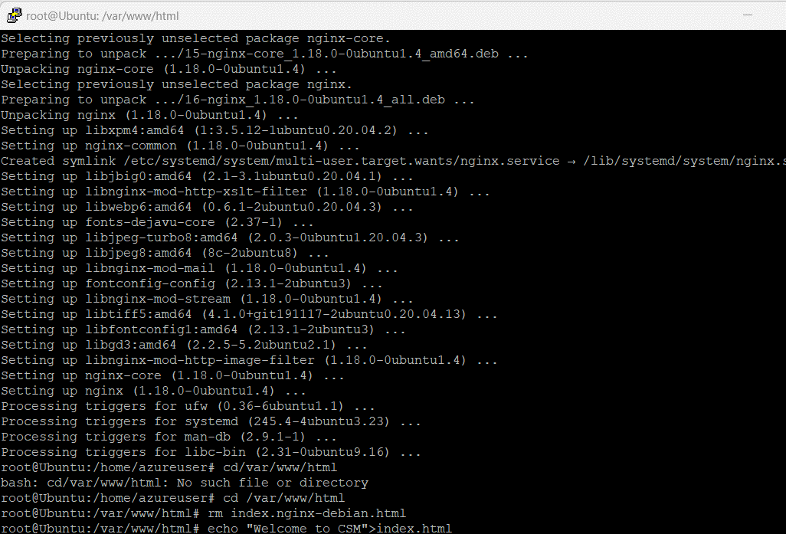

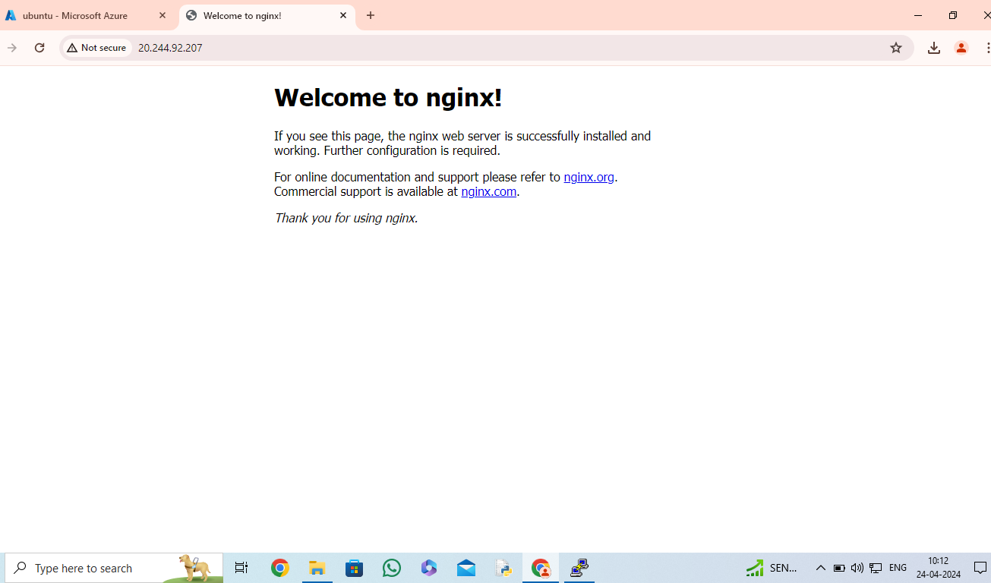

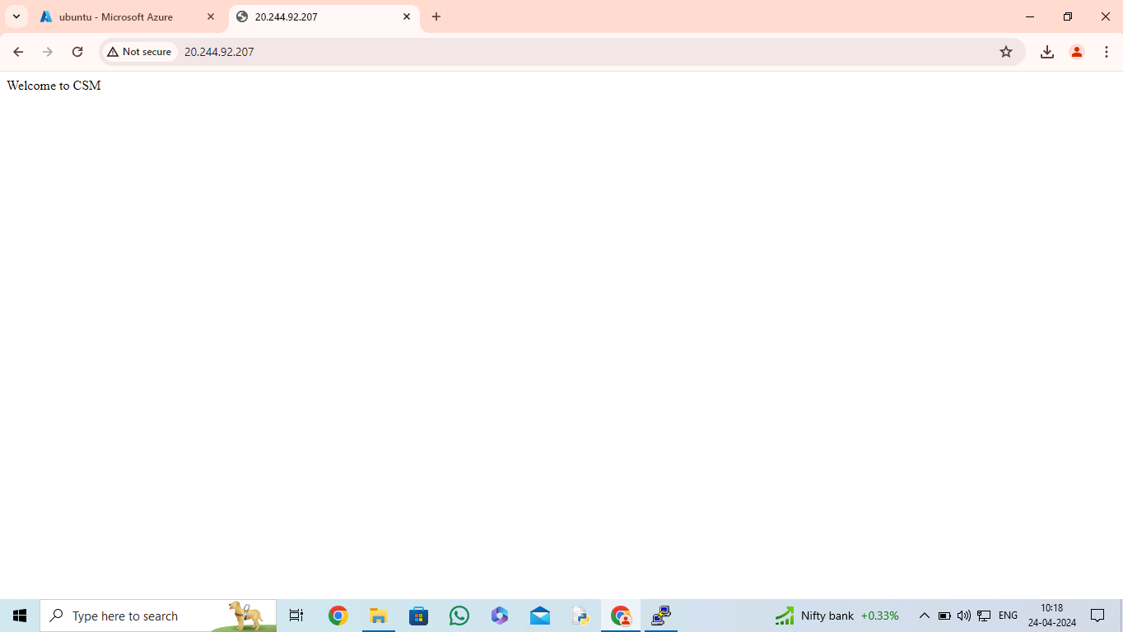

**Q9) Setup and configure AZURE web server for windows server (IIS).**

**Step-1:** Sign in to your Microsoft Azure account.

**Step-2:** Go To Virtual machine, and click on “Create” to create a window virtual machine.

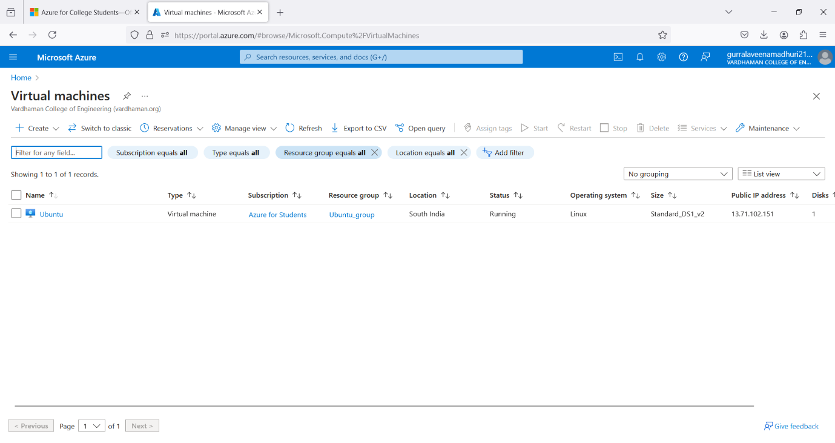

**Step-3:** Fill the details in that window by creating a “Resource Group”, Zone: Asia, Image: window, Select the disk storage and so on. After that click on “Create + Review”. And Finally click on “Create”

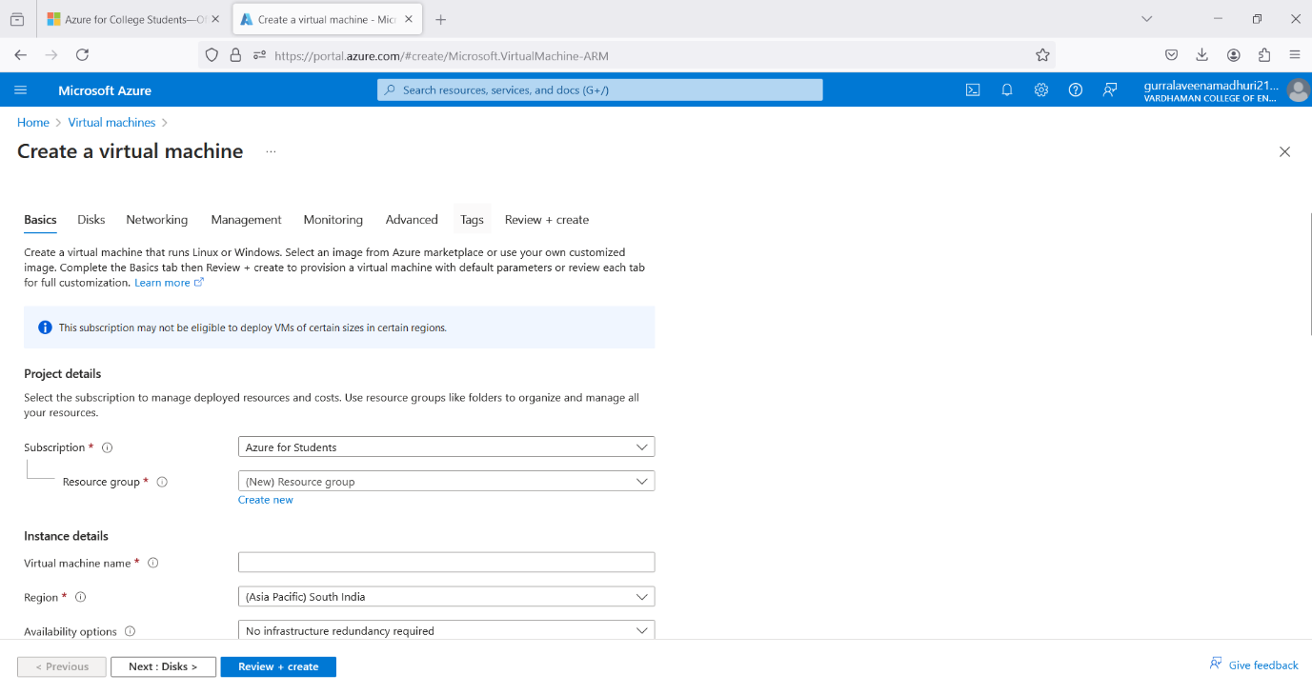

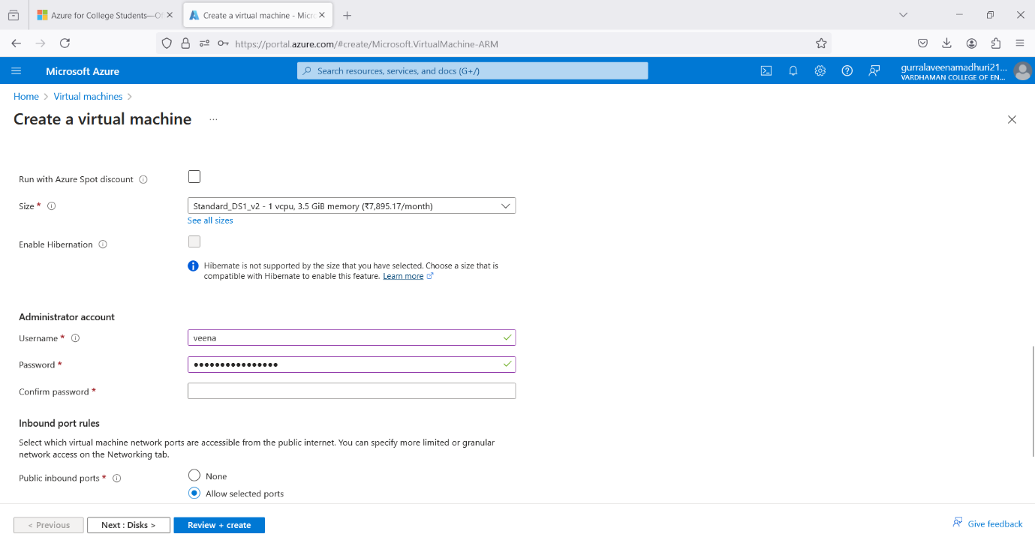

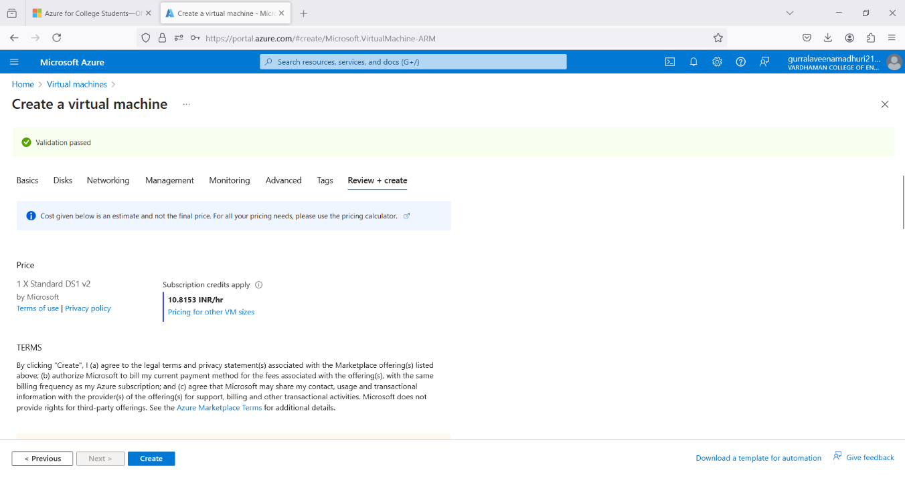

**Step-4:** After Deployment is over, Go to the remote desktop connection.

**Step-5:** Firstly, copy the public IP Address of that created virtual machine.

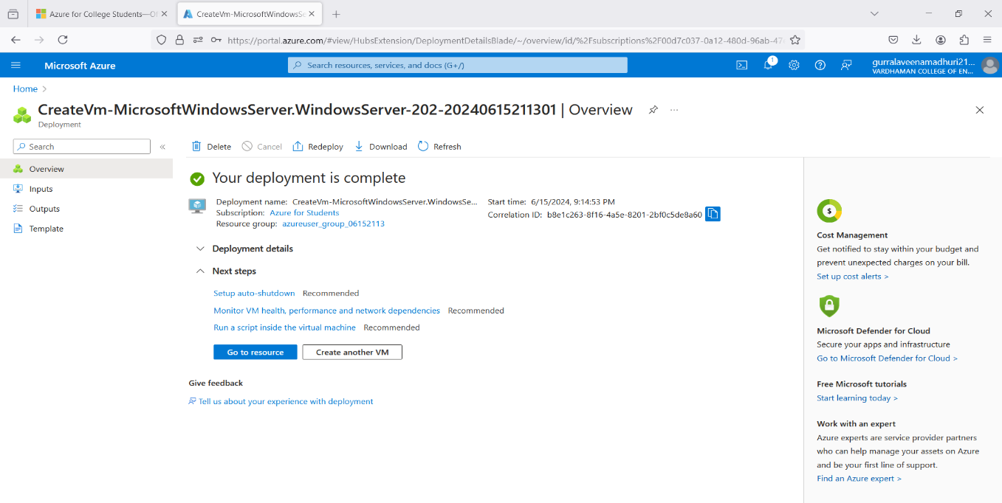

**Step-6:** By using that copied IP Address open the window virtual machine through remote desktop connection.

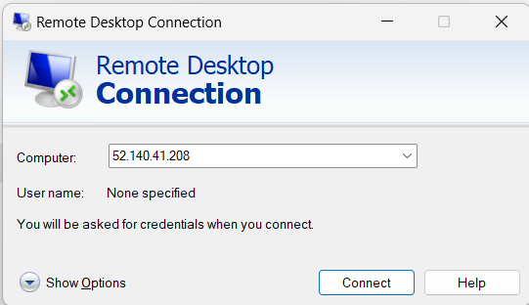

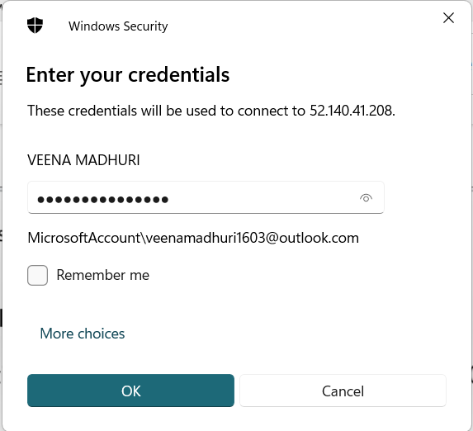

**Step-7:** When remote desktop will start (windows VM) you can see there will be Sever Manager will be opened and in that you can see Configure this local server, click on “Add roles and features”.

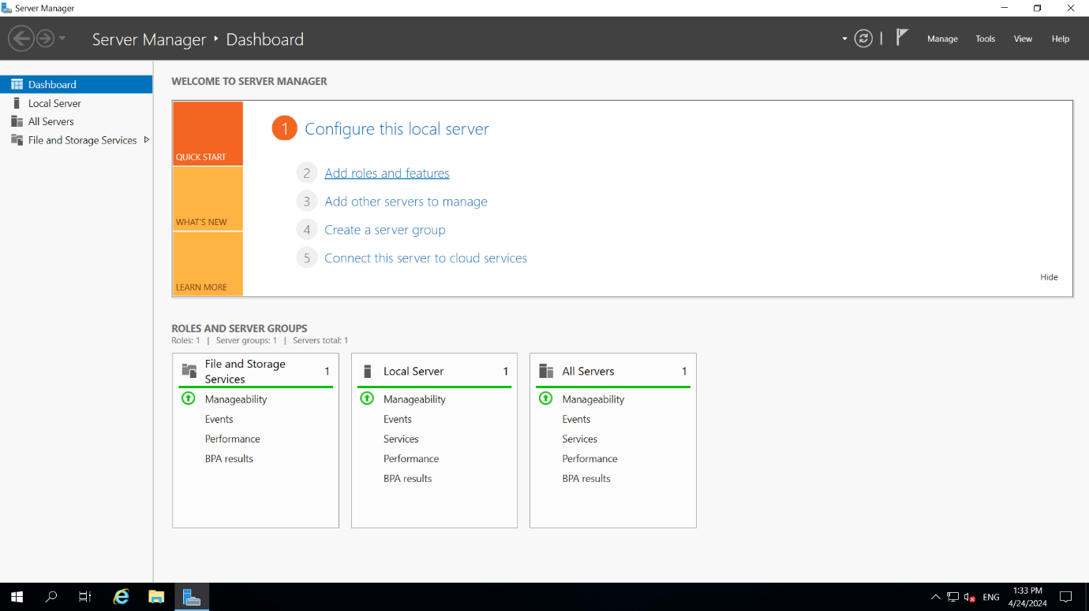

**Step-8:** Click on next, next and in Server Roles select Web Server (IIS) click on add feature, click on next, next till you can get install button and click on install.

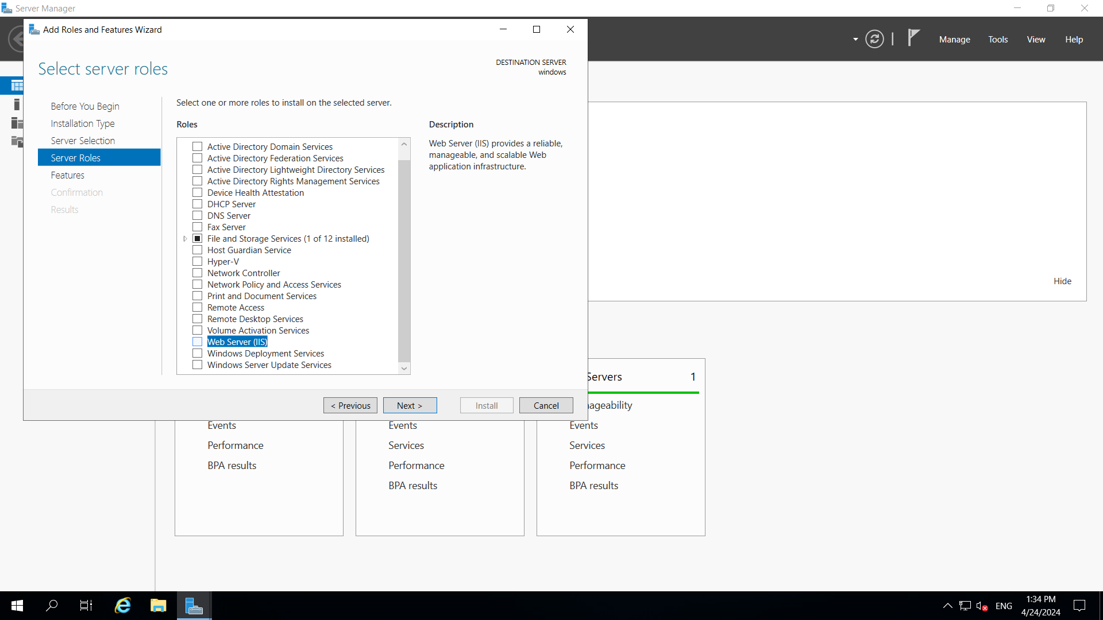

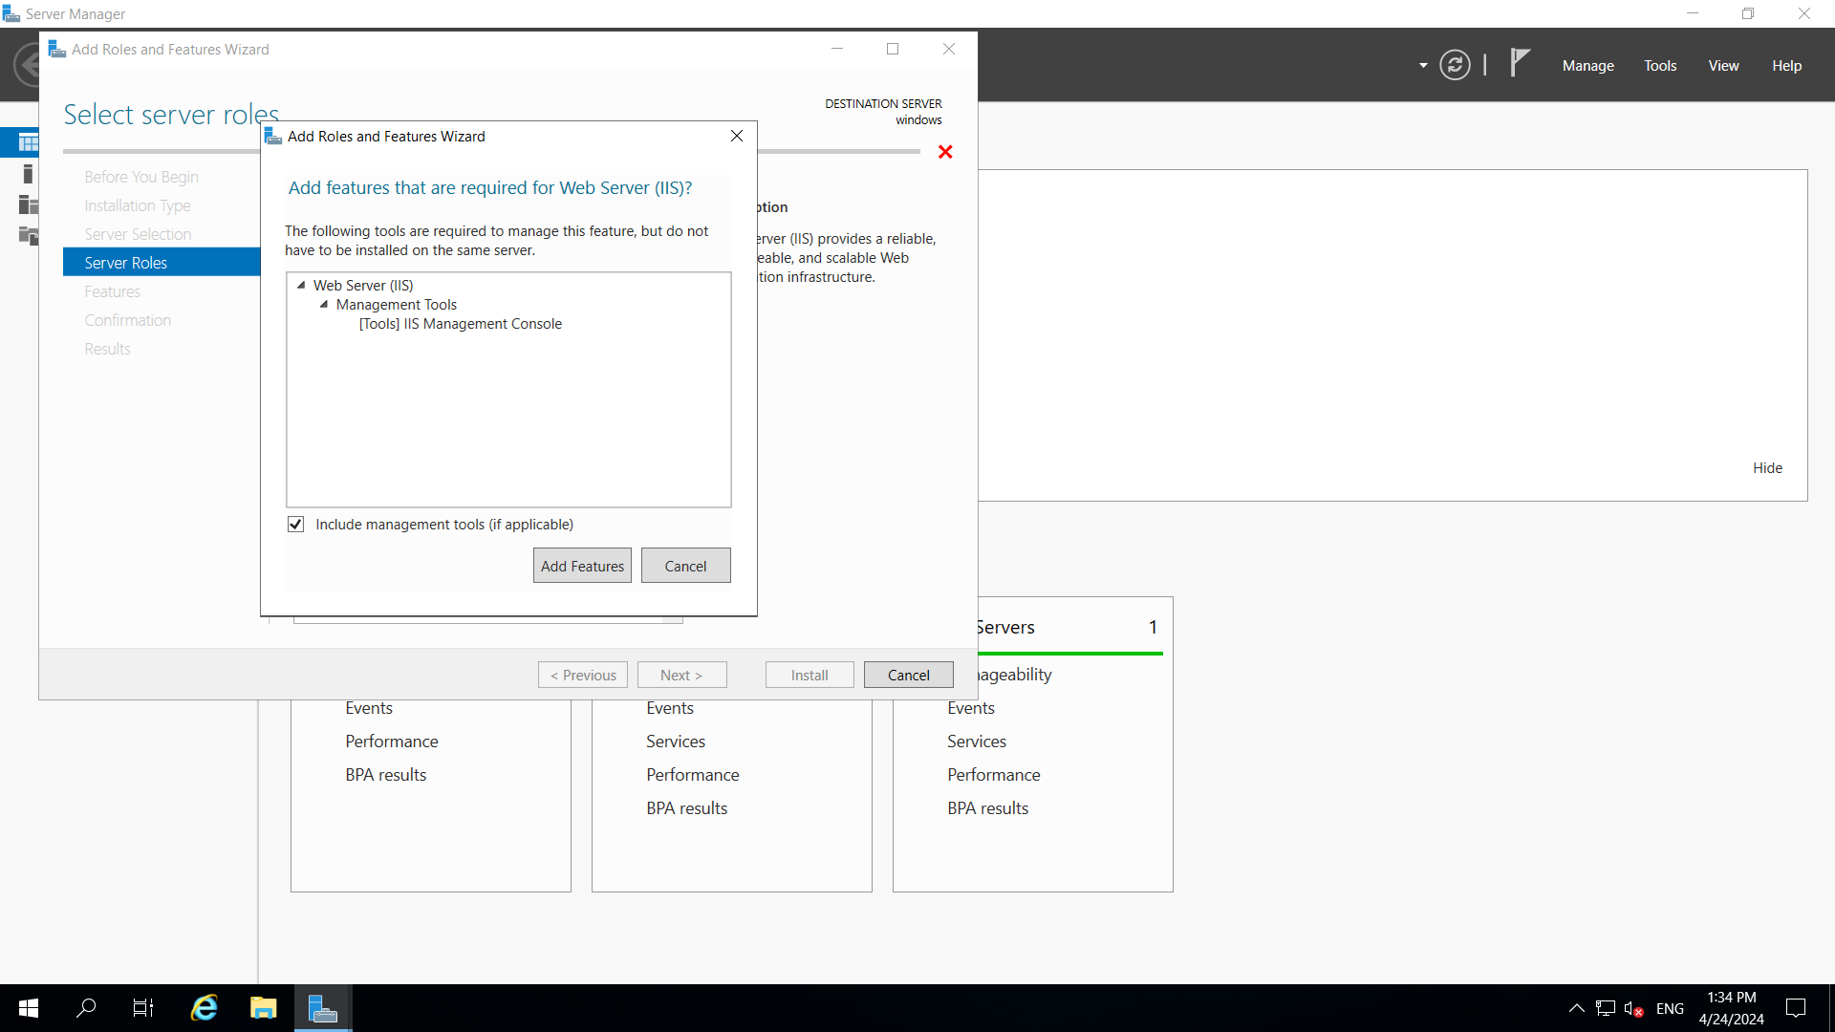

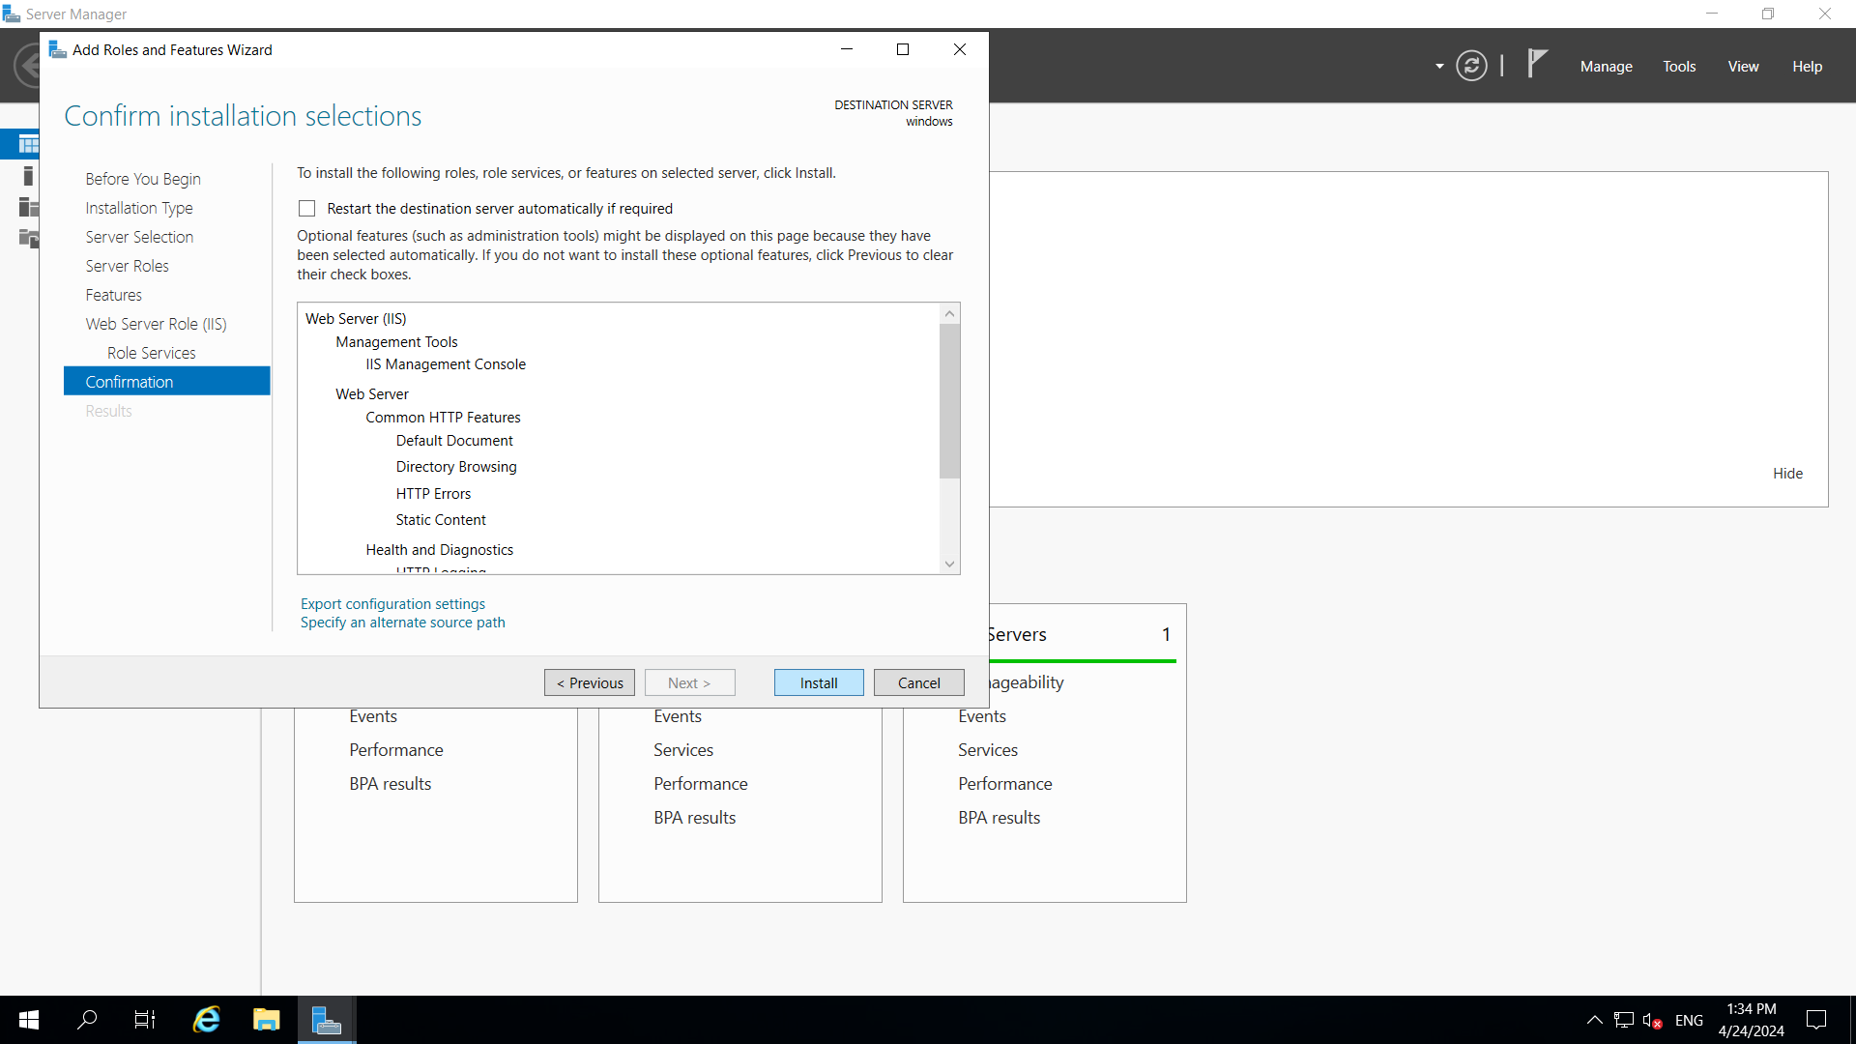

**Step- 9:** paste the public ip address in desktop browser and you can see.

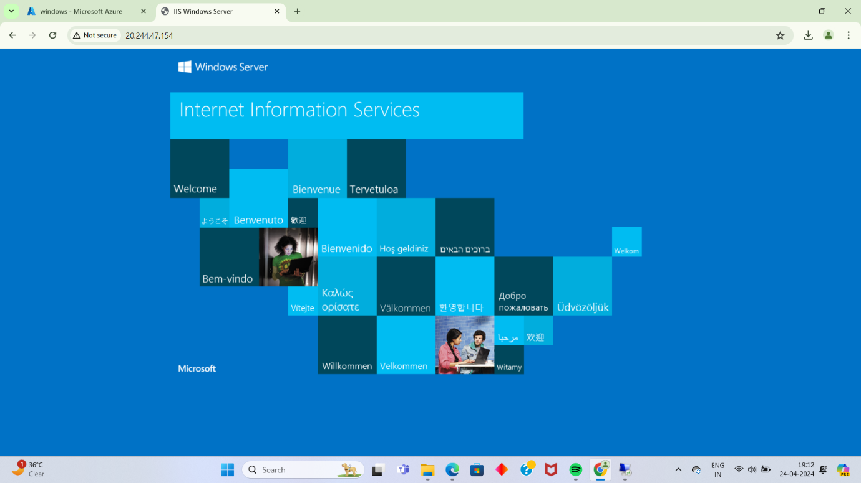

Now to remove this all information first of all create index.html in desktop and

that should paste in the specified location of remote desktop VM that is

ThisPC->windows(c)- >inetup->wwwroot and remove iistart png.

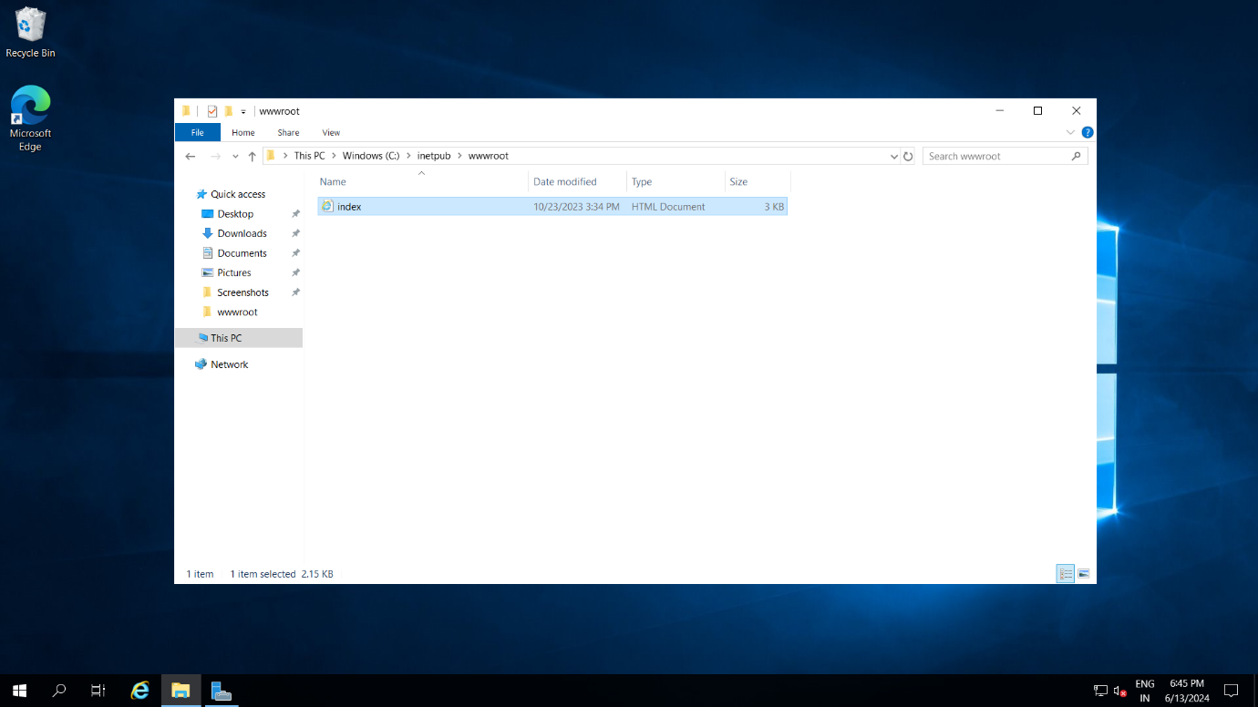

**Step-10:** Refresh the browser page.

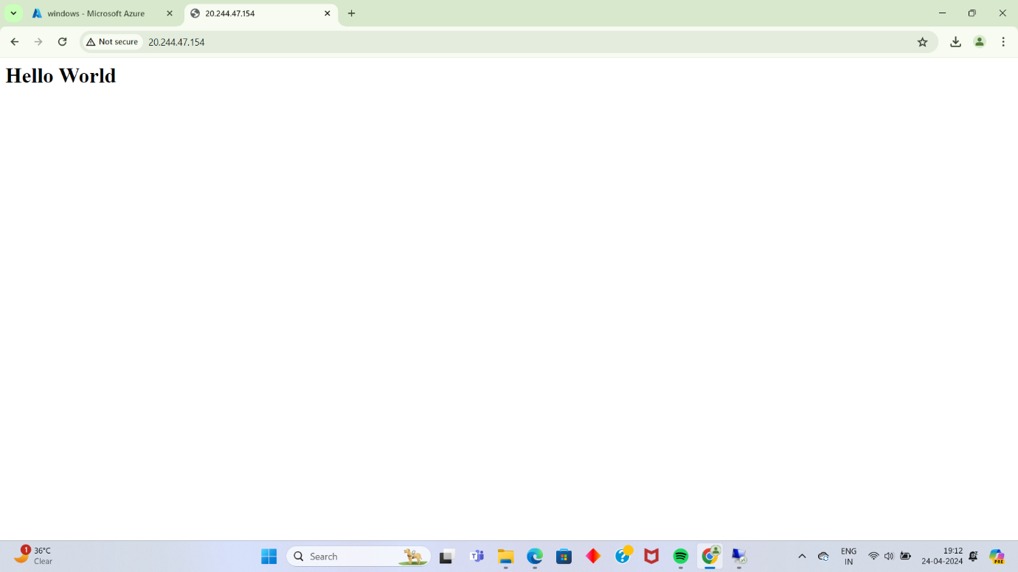

**Q10) How we are adding new users, login credentials, changing owner, create authorized key files.**

**Step-1:** Sign in to your Microsoft Azure account.

**Step-2:** Go To Virtual machine, and click on “Create” to create a window virtual machine.

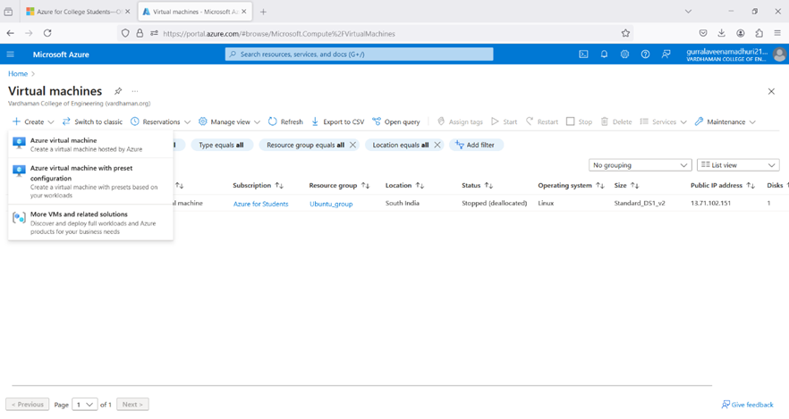

**Step-3:** Fill the details in that ubuntu by creating a “Resource Group”, Zone: Asia, Image: ubuntu, select “SSH”, Select the disk storage and so on. After that click on “Create + Review”. And finally click on “Create”.

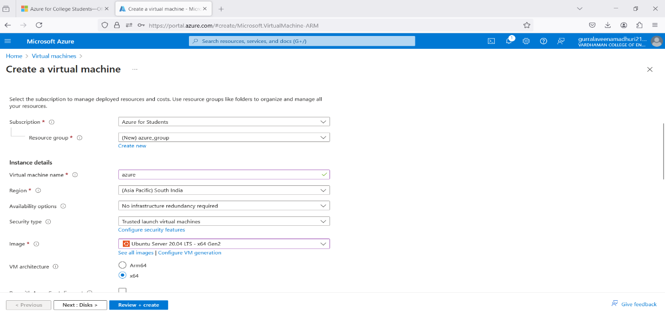

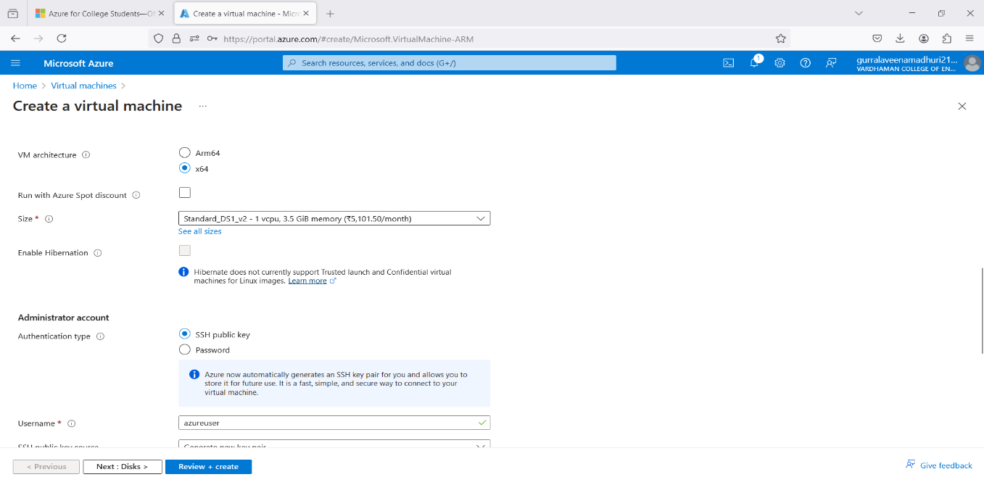

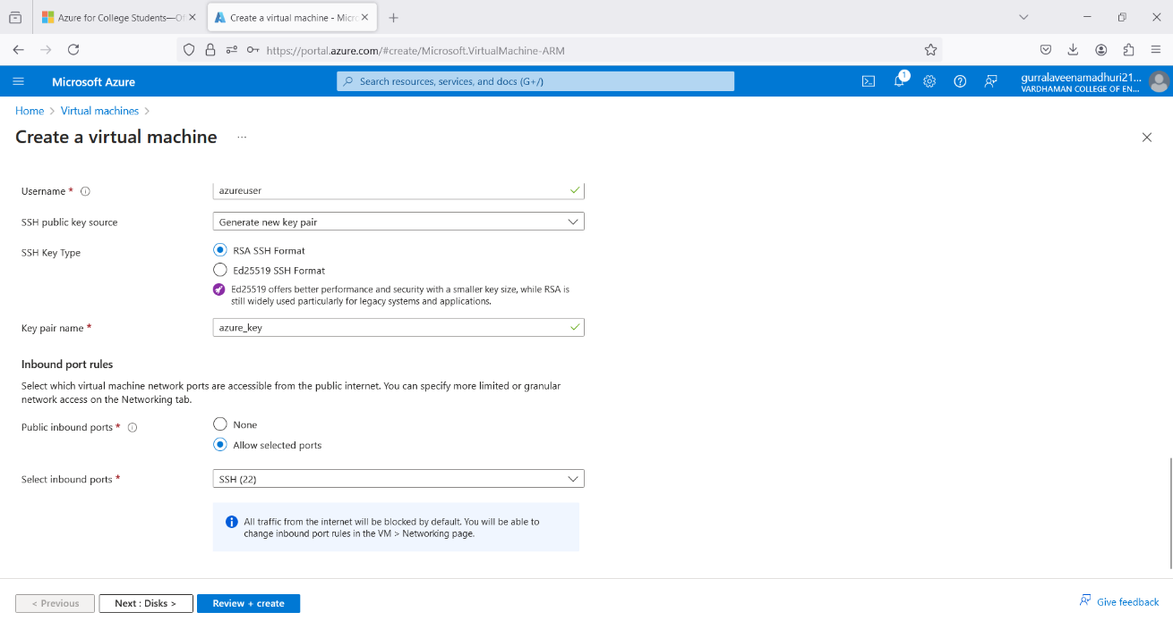

**Step-4:** After Deployment is over, Go to the remote desktop connection.



**Step-5:** Firstly, copy the public IP Address of that created virtual machine.

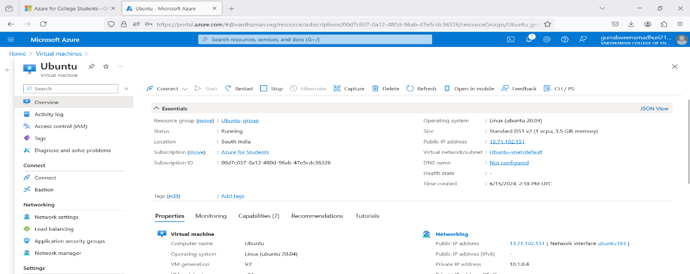

**Step-6:** Go to putty gen and click on load the key generator that you have downloaded.

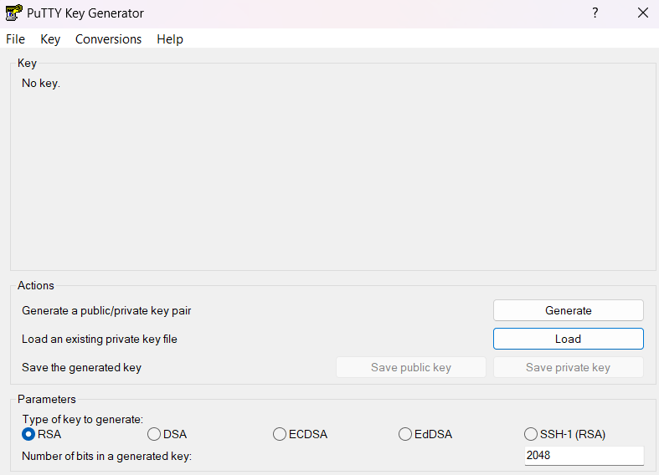



**Step-7:** In putty, put the Copied IP Adress into it, and then go to ssh->auth->credentials and the put the generated private key.



**Step-8:** A login page will be opened in that type your username and you will be into the ubuntu.

**Step-9:** Login into your Ubuntu VM using your username and type the following commands.

To add new user in Linux server:

$sudo useradd -m veena

To set new password:

$sudo password veena

Enter new password and Retype password.

To modify login credentials:

$sudo usermod -aG sudo veena

To switch the user:

$sudo su veena

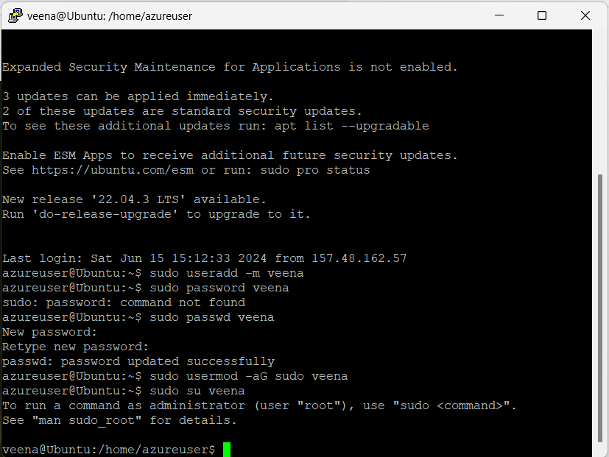

**Q11) Create a Windows VM and transfer files from desktop to remote desktop VM.**

**Step-1:** Sign in to your Microsoft Azure account.

**Step-2:** Go To Virtual machine, and click on “Create” to create a window virtual machine.

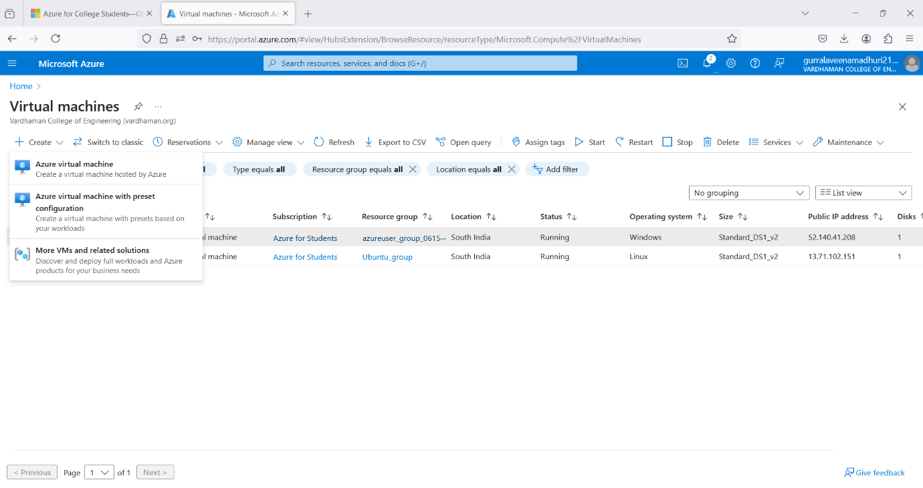

**Step-3:** Fill the details in that window by creating a “Resource Group”, Zone: Asia, Image: window, Select the disk storage and so on. After that click on “Create + Review”. And finally click on “Create”

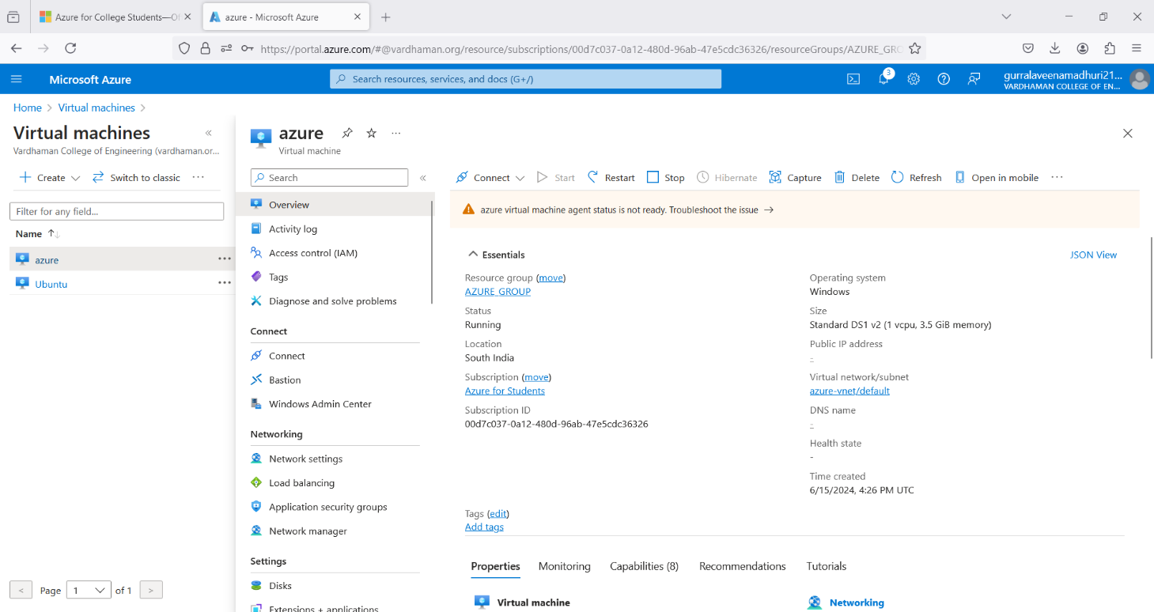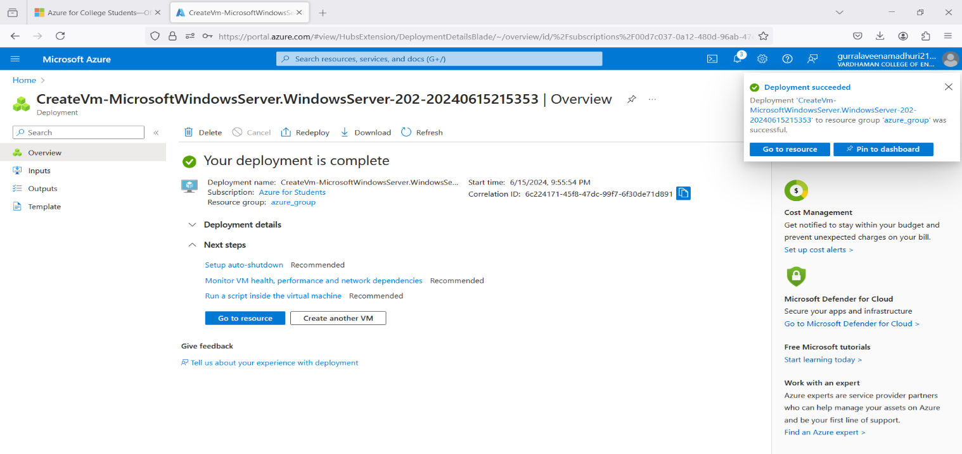**Step-4:** After Deployment is over, Go to the remote desktop connection.

**Step-5:** Firstly, copy the public IP Address of that created virtual machine.



**Step-6:** By using that copied IP Address open the window virtual machine through remote desktop connection.



**Step-7: Minimize the Remote desktop and copy file from desktop.**

**Right click in remote desktop and click on paste.**

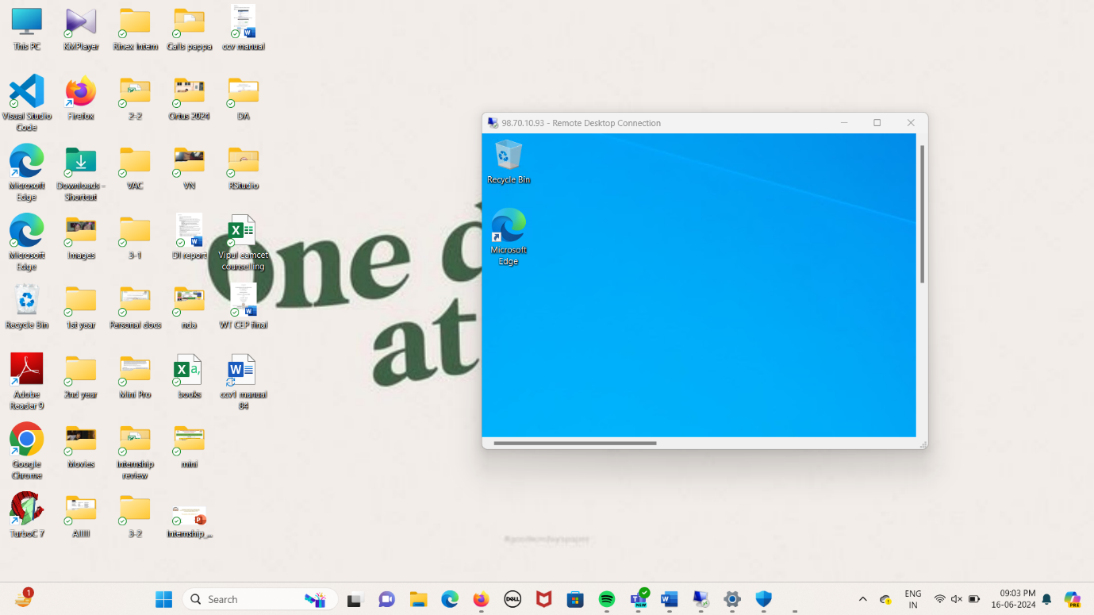

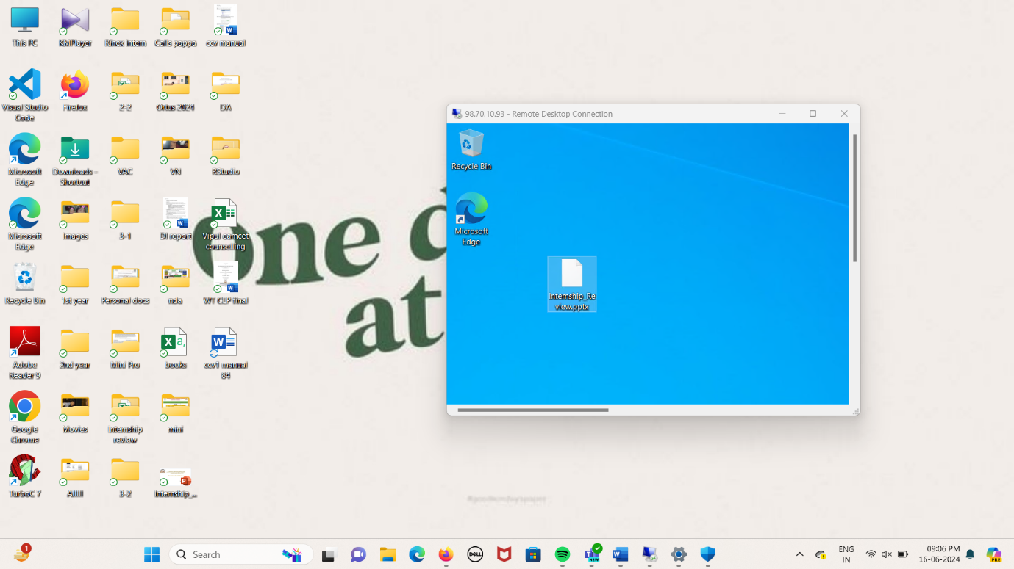

**12Q) How to attach and detach data disks to Windows server in azure data center**

**Steps:-**1) Create a Virtual name with VM name as "UbuntU" with username &password

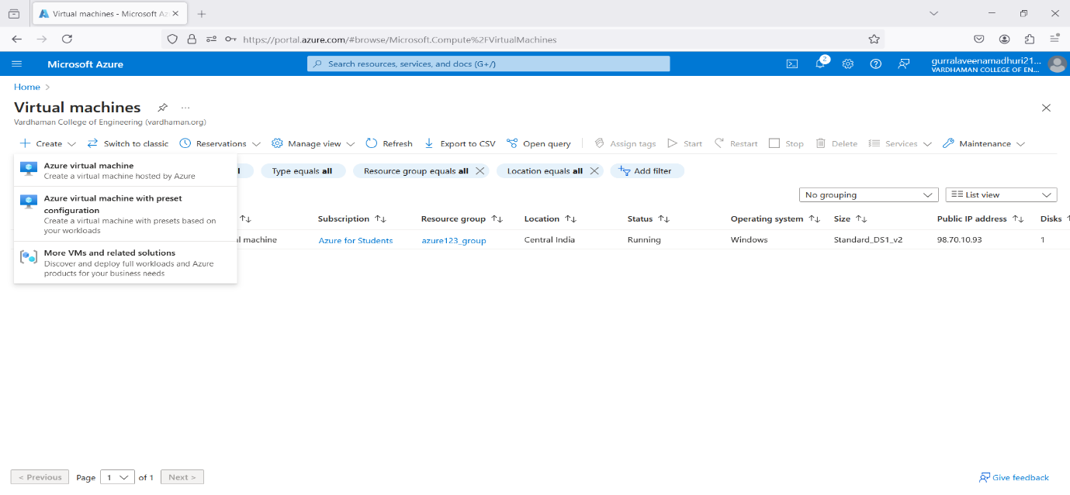

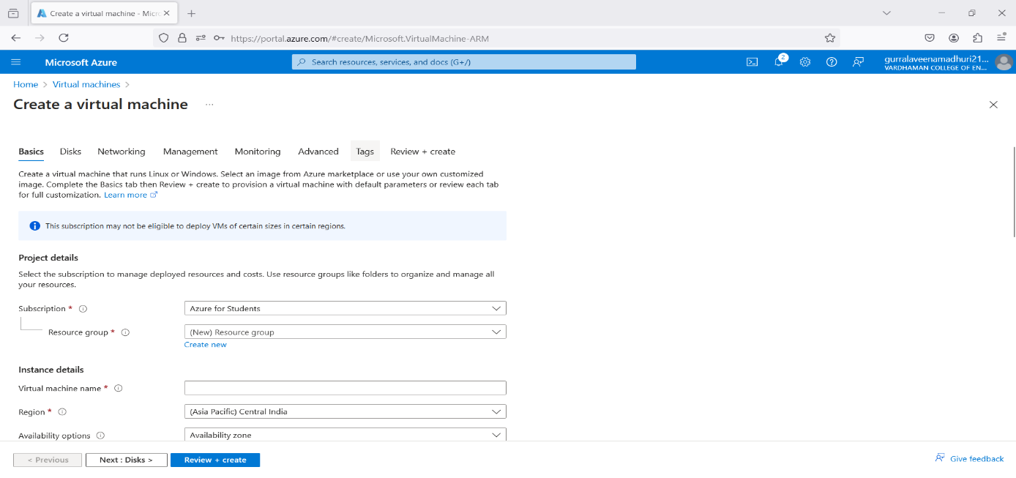

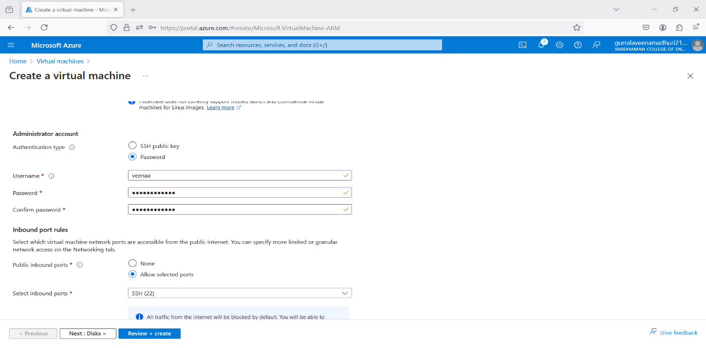

2) click on "Next:Disks>"

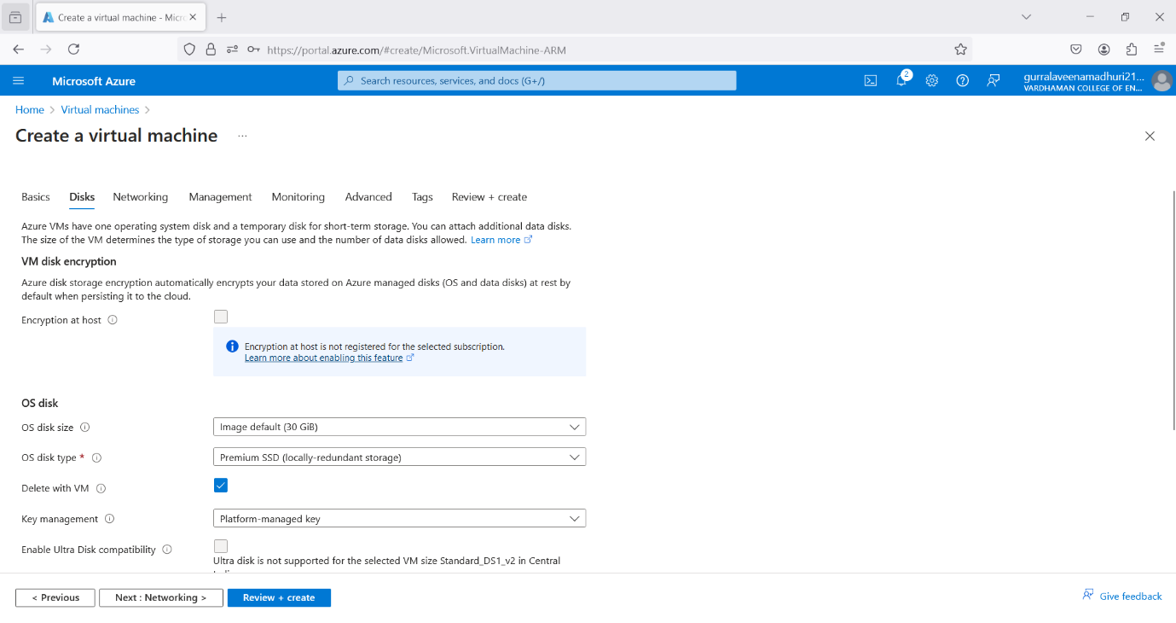

3) Click on "Create & attach a new disk"

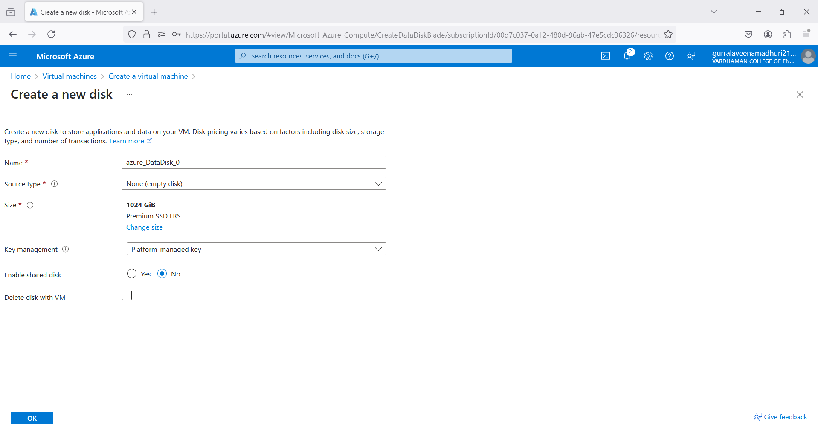

4) Click on “change size”

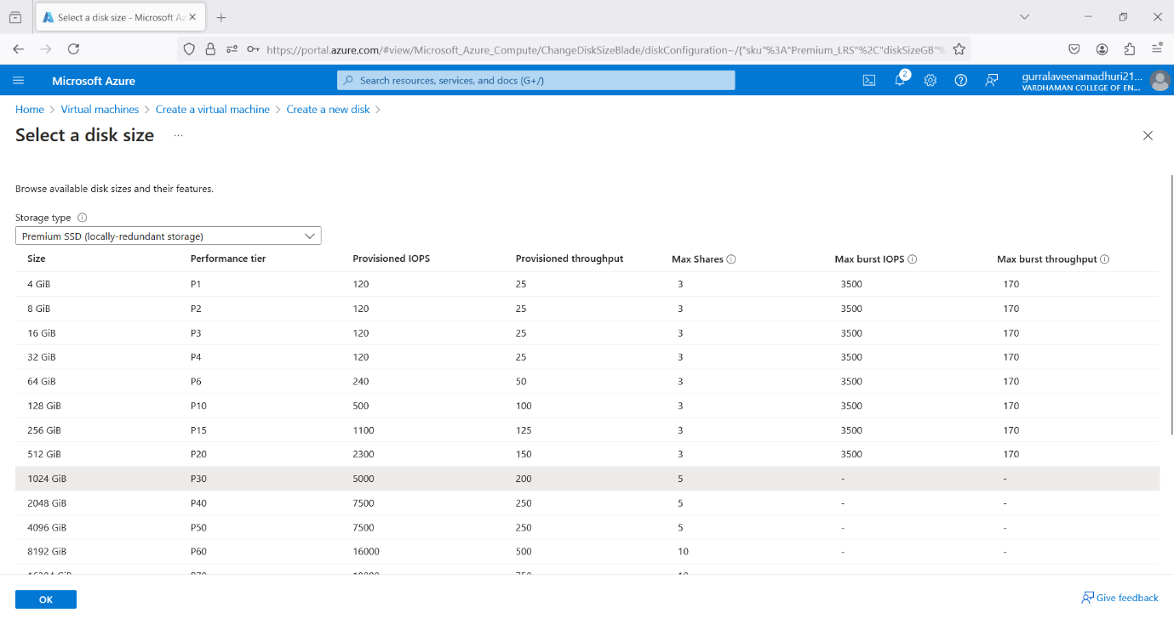

5) Customize data size to 4 GiB and click on OK

6) Enable delete with VM and click on OK

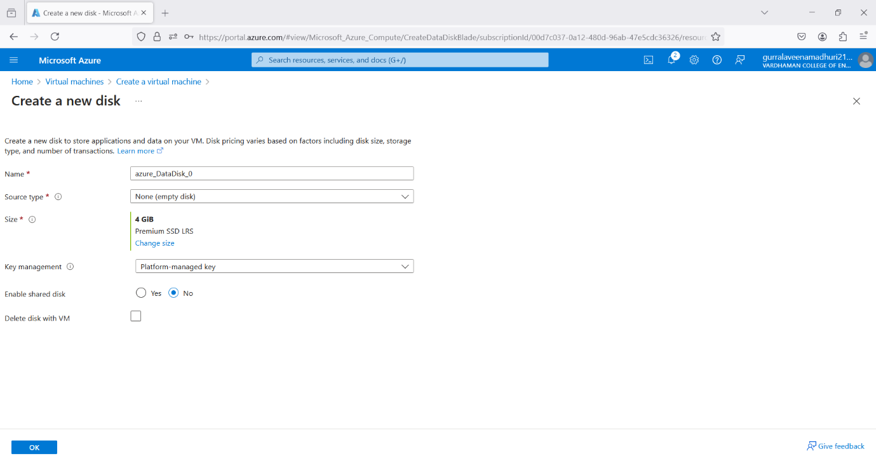

7) Click on "Review+create" & click on create

8) Click on "Go to resource group"

9) Copy public IP Address

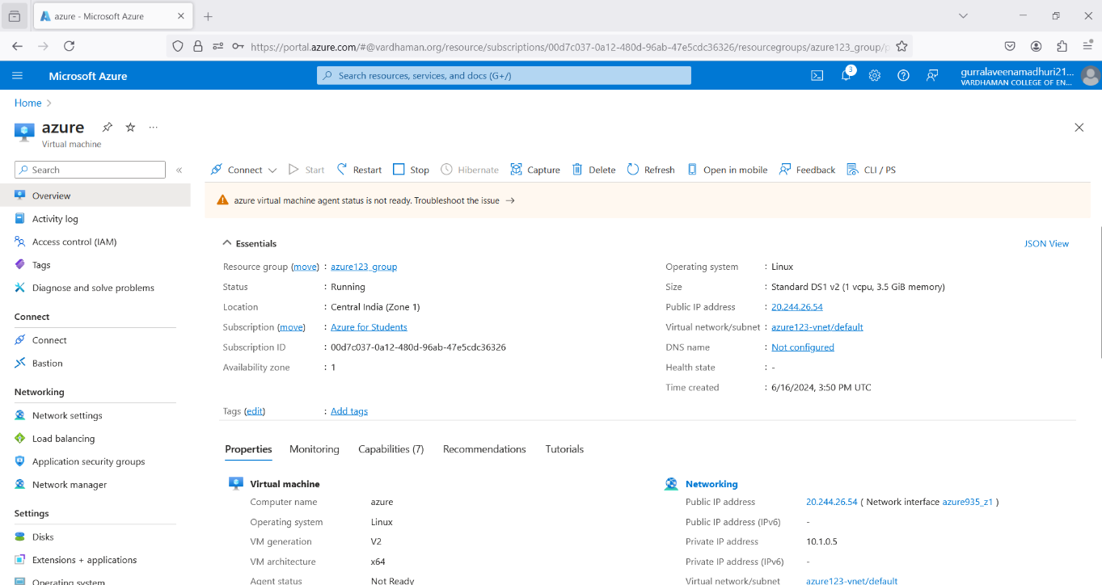

10) Open Remote Desktop Connection in your windows/system and paste the public IP Address

11) Click on “More choices”

12) Click on “Use a different account”, enter the credentials and click on OK

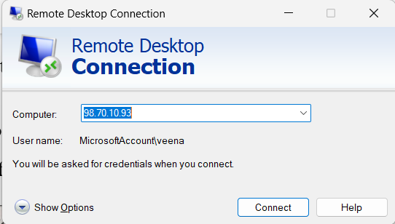

13) Click on yes and now the data disks are attached to the windows server

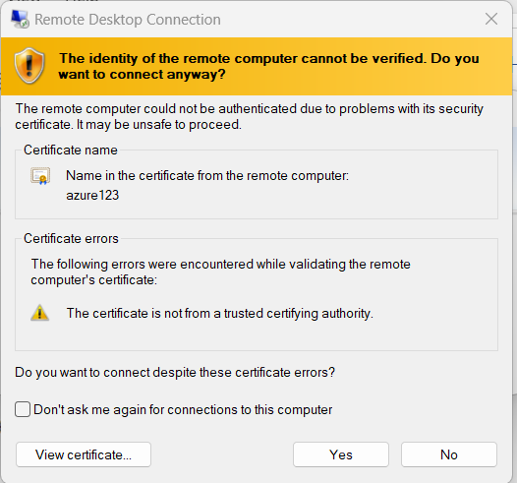

14) Click on “Disks” in your VM and you can see the attached data disks to the windows server

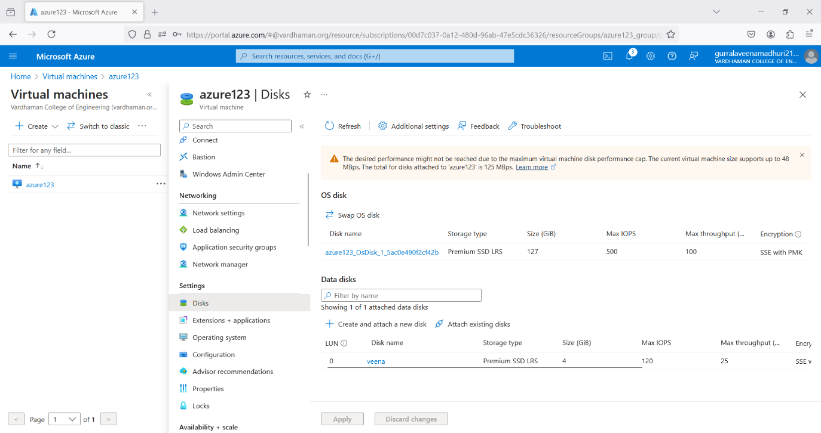

15) Detach the data disks from the windows server by clicking on the detach symbol

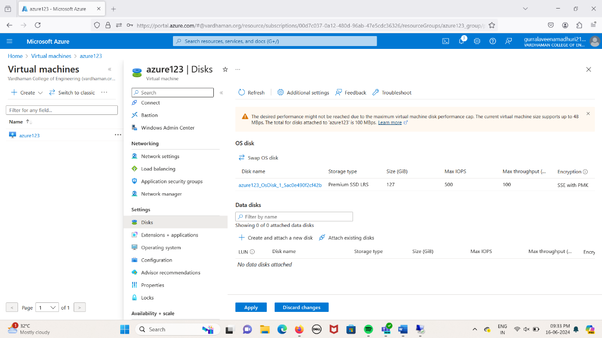

16) Click on “Apply”

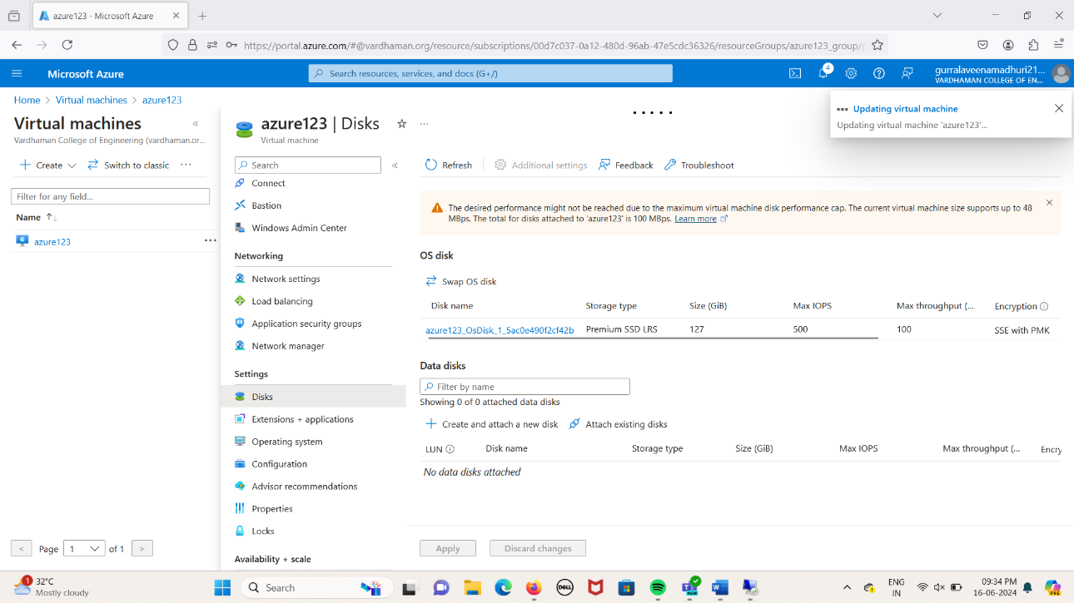

17) Now the data disks are detached from the windows server

**13Q) How to add data disks to linux server in azure data center**

**Steps:-**

**Step 1 :** Create a Virtual Machine with username &password.

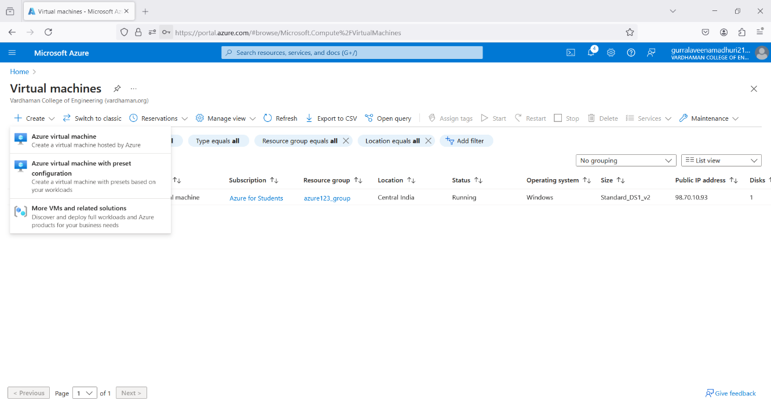

**Step 2 :** click on "Next:Disks>"

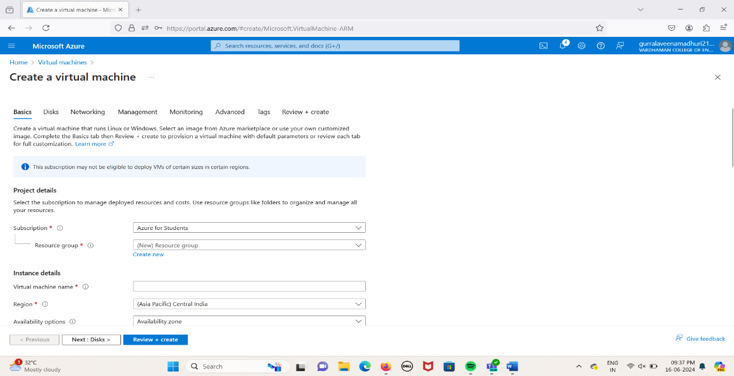

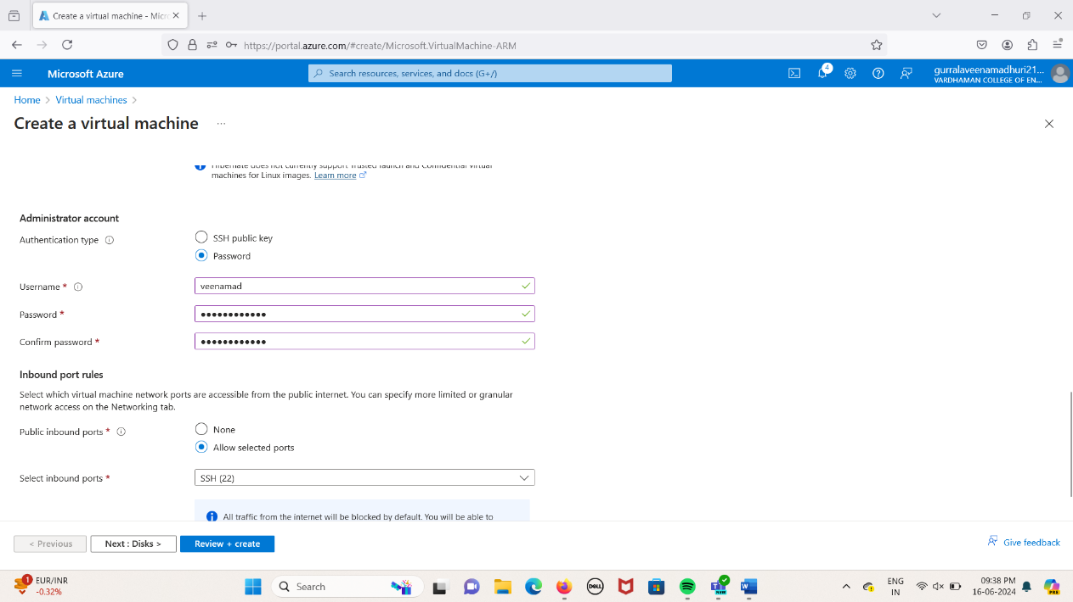

**Step 3 :** Select

OS disk size -------30GB

OS disk type ------Premium SSD(LRS)

enable "Delete with VM”

**Step 4 :** Click on "Create & attach a new disk"

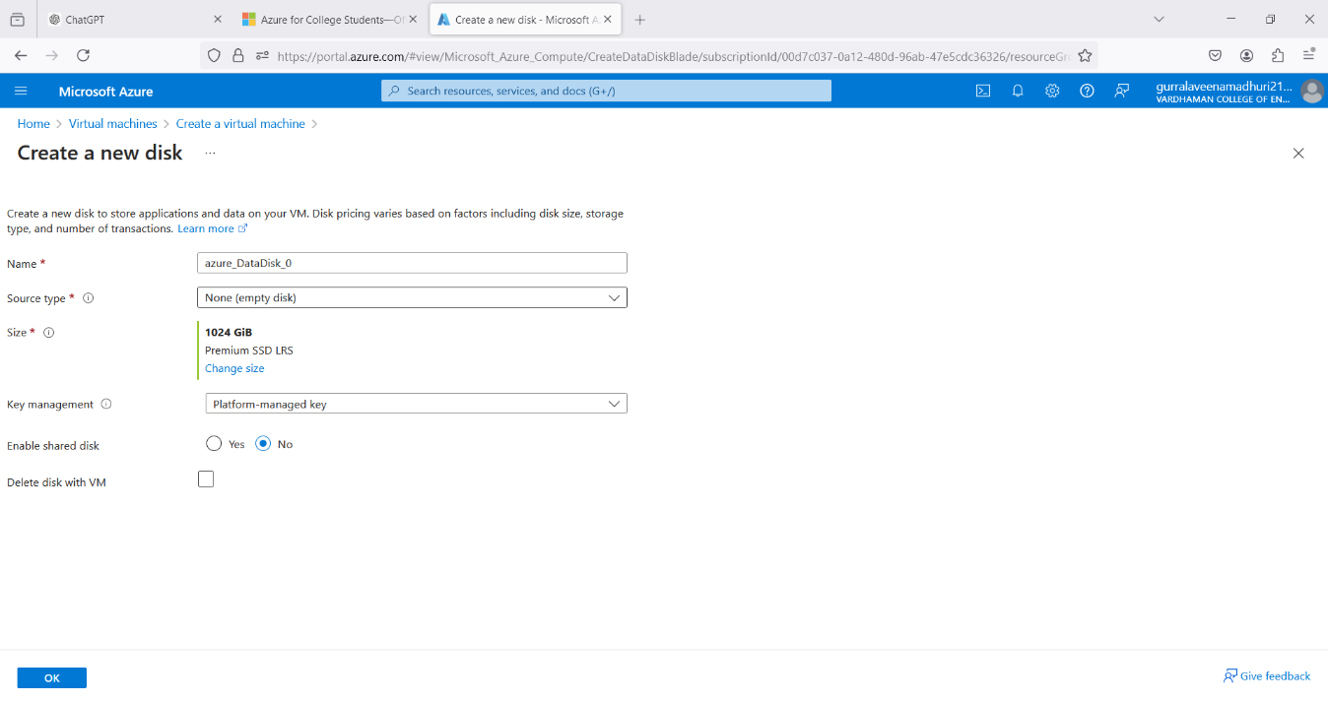

**Step 5 :** Select Source type -------None (empty disk), Size -------1024GB, Key manager ------- Platform managed key, Enable shared disk -------NO and finally click on OK

**Step 6 :** Select Storage type -------Premium SSD(LRS), Custom disk size (GB) ------5 click on OK

**Step 7 :** Click on "Review + create" & click on create

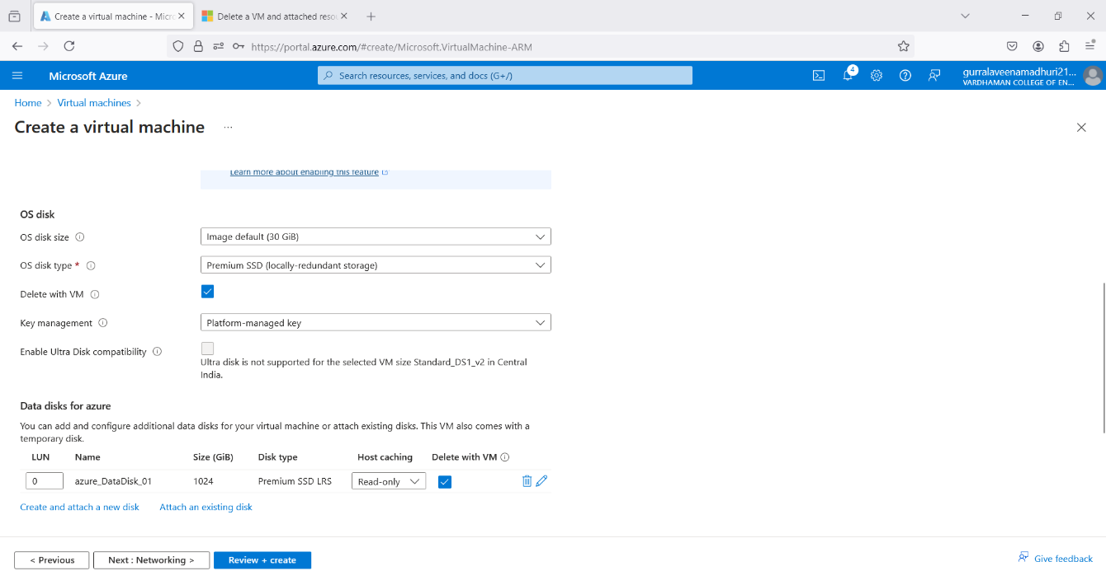

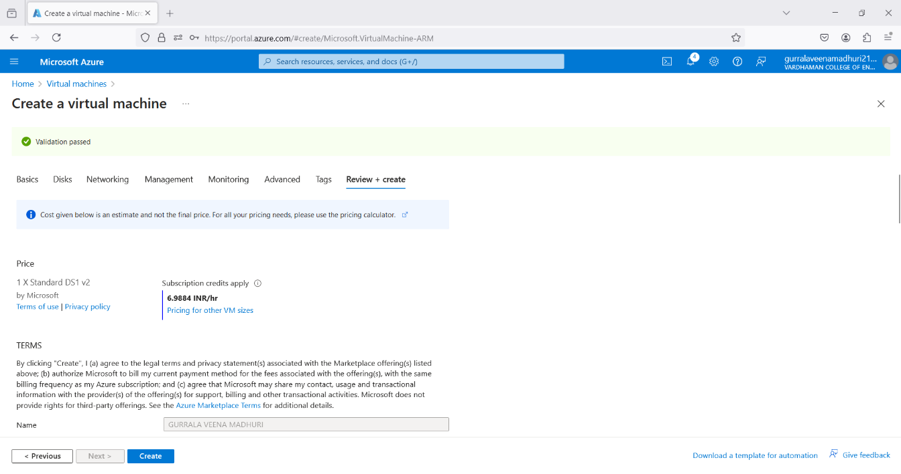

**Step 8 :** Click on "Go to resource group" 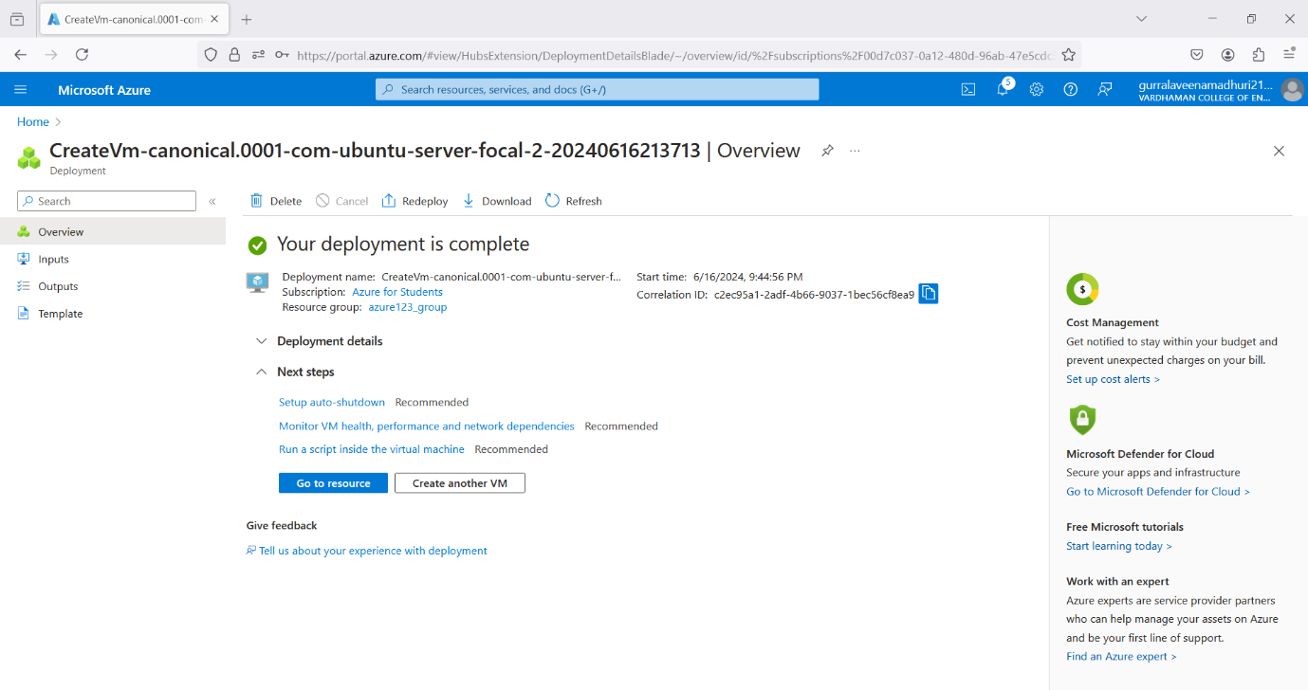

**Step 9 :** Copy public IP Address

**Step 10 :** Open "PUTTY" & paste the IP adress and click on "open" 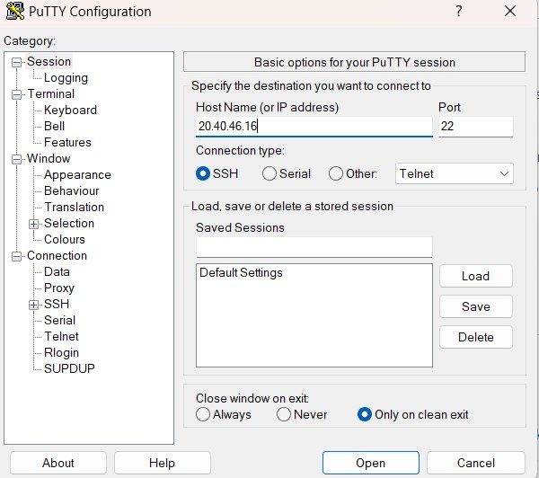

**Step 11 :** Login into it with username and password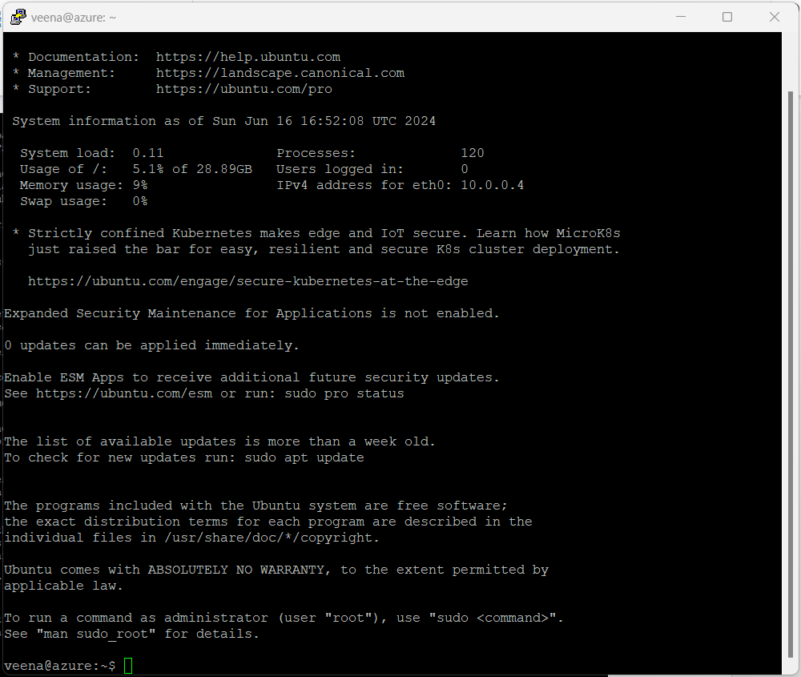

**Step 12 :** Type the below commands

$ df -hT

$ lsblk

$ sudo filoe -s/dev/sdc

$ sudo mkfs -t ext4 /dev/sdc

$ mkdir test

$ sudo mount /dev/sdc/ test

$ cd test

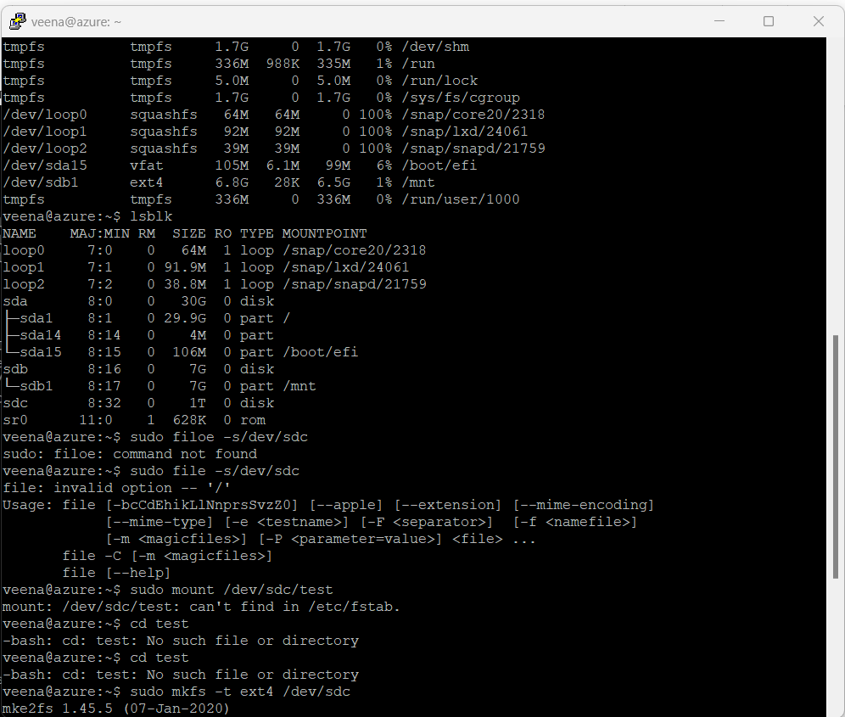

**Step 13 :** Click on Apply

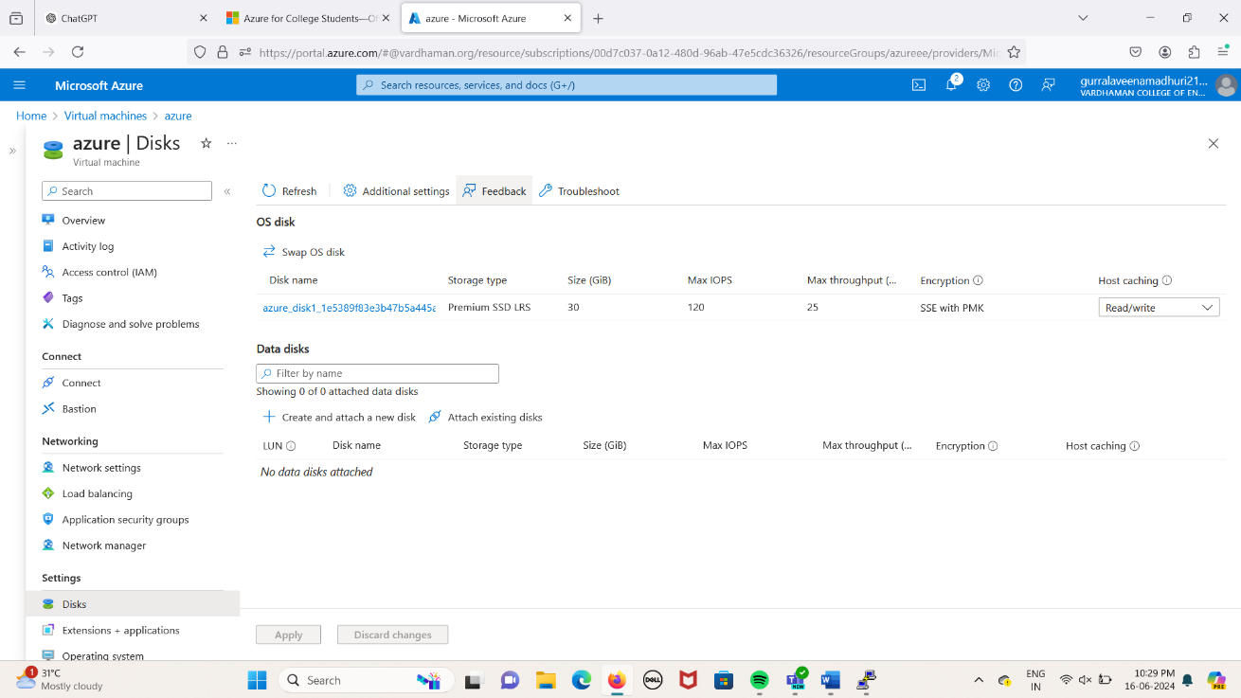

**Q14) Move Server Files from one Resource Group to another**.

**Step-1:** Create ResourceGroup1, ResourceGroup2 and a Virtual machine on ResourceGroup1.

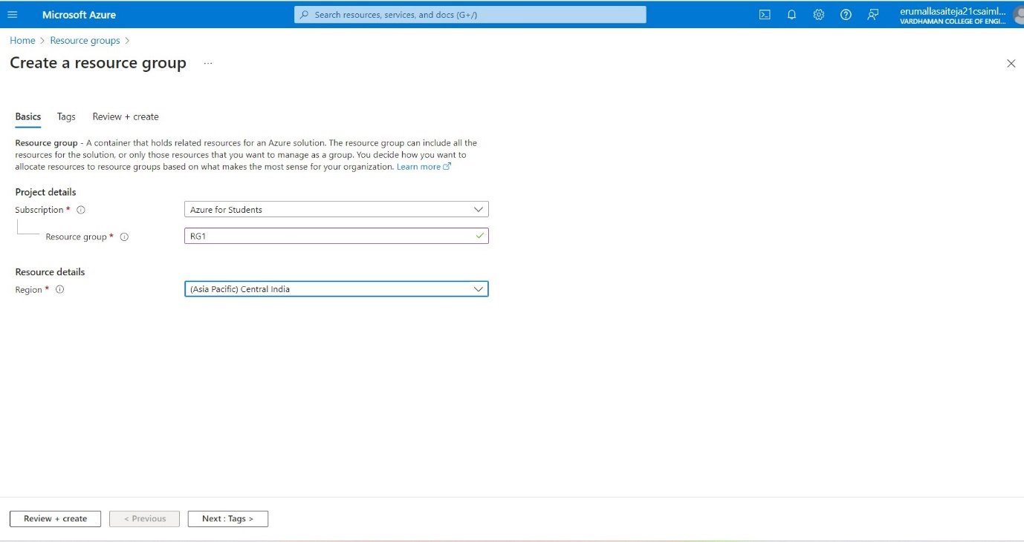

****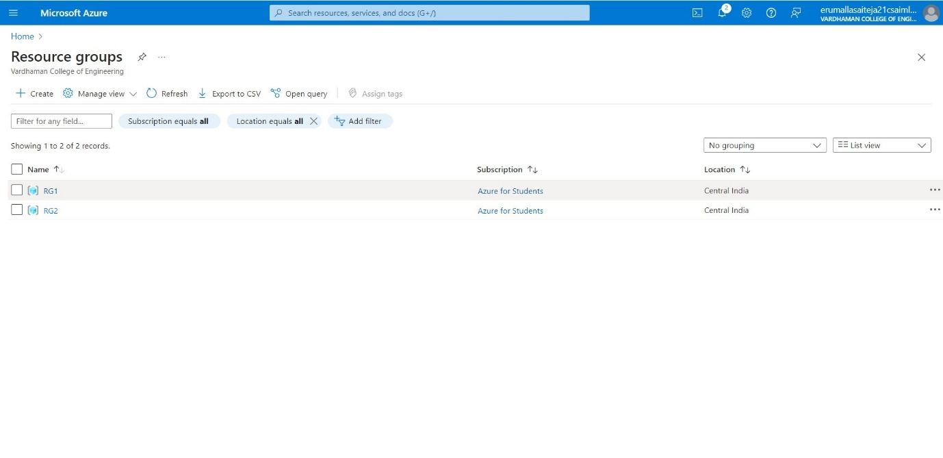

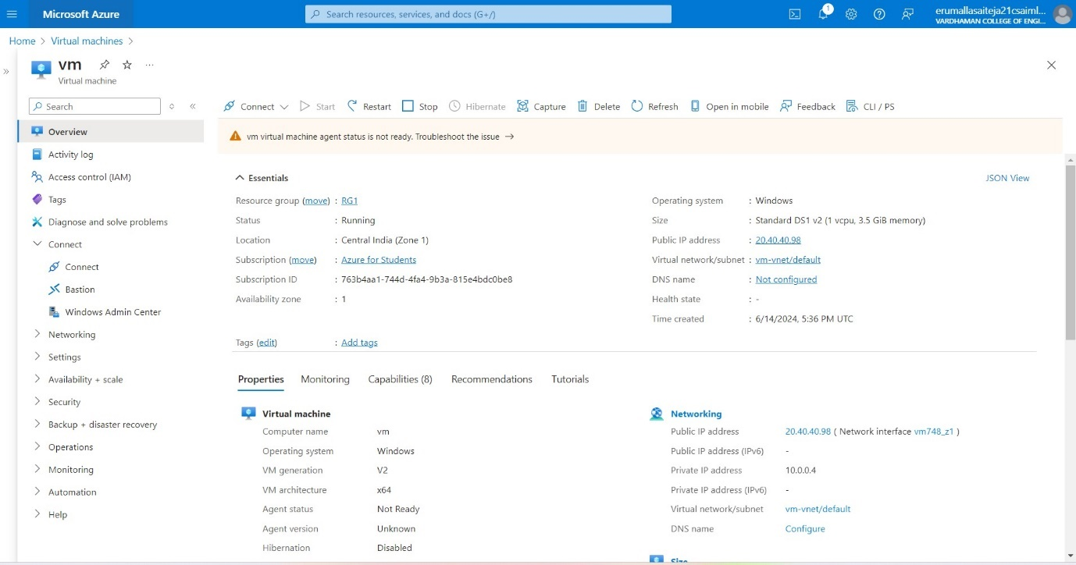

**Step-2:** Select all the resources from ResourceGroup1 and then click on Move->Move to another resource group.

 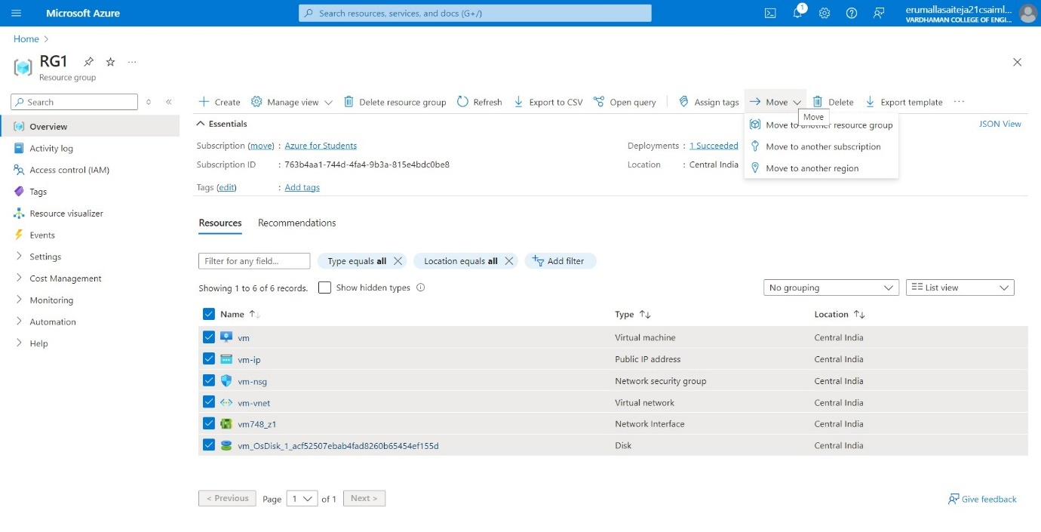

**Step-3:** Select the target Resource Group as ResourceGroup2 and click on move.

****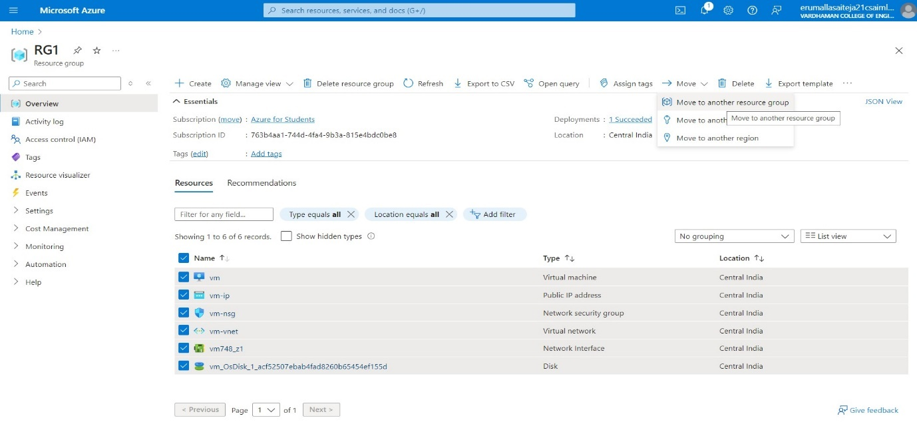

****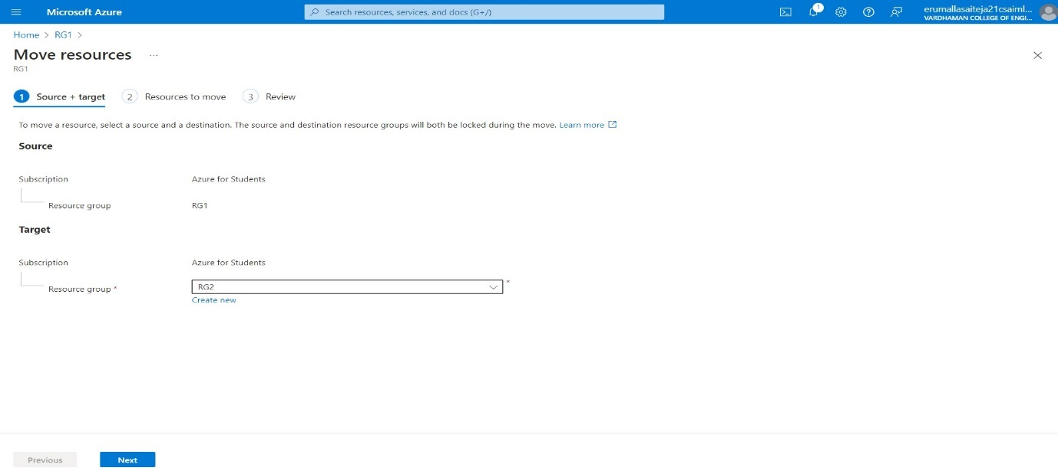

****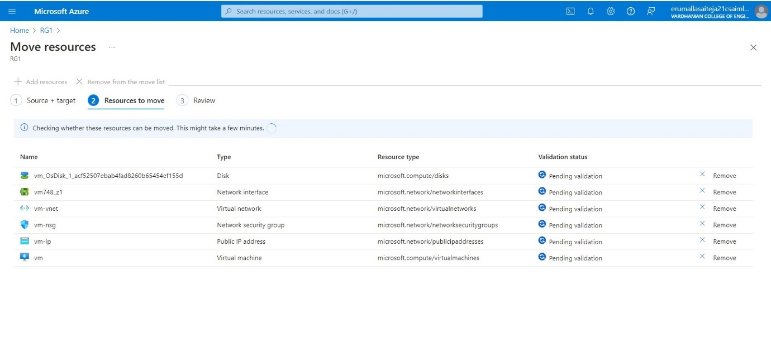

****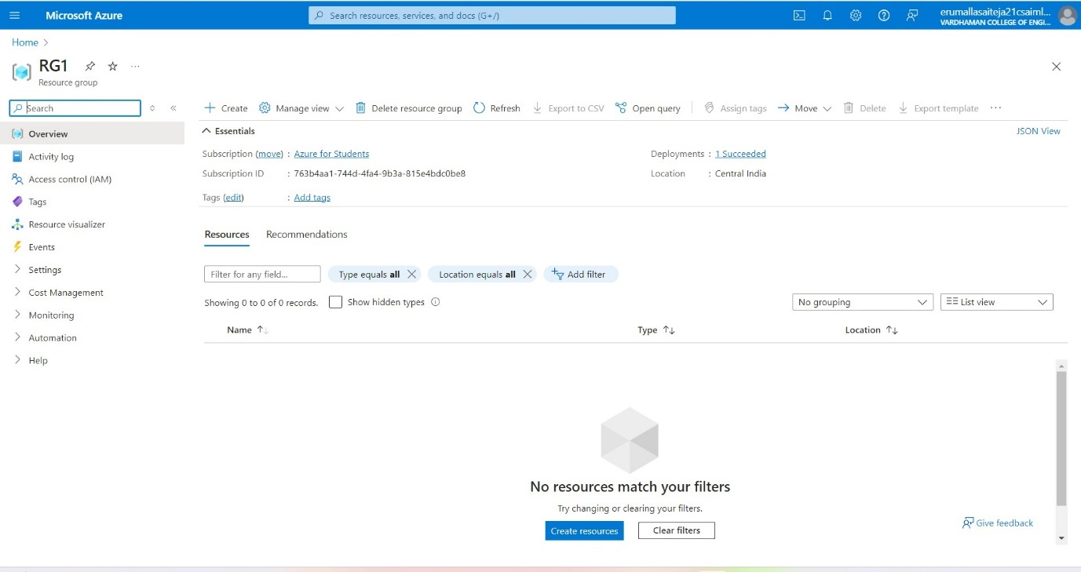

****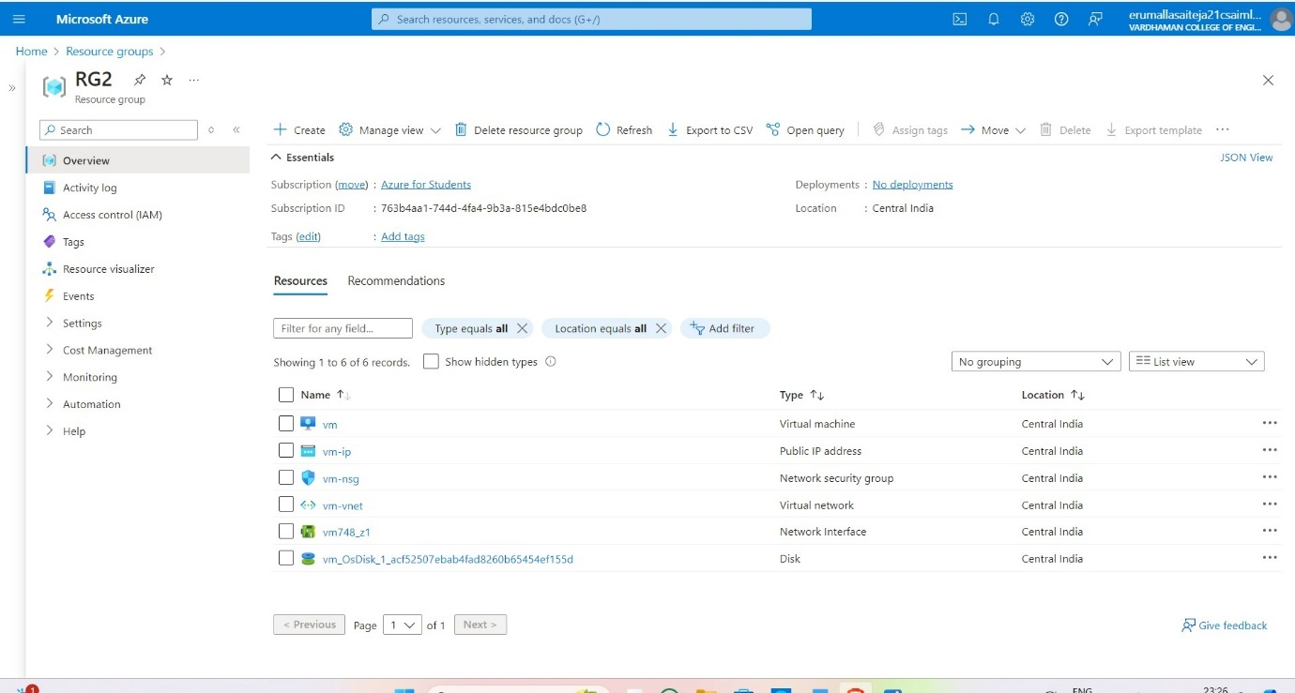

**Q15) Create Azure Storage Account, Container – Upload and Delete Objects(blob) in it.**

**Step-1:** Click On Storage Account and Create one and select redundancy as GRS/LRS.

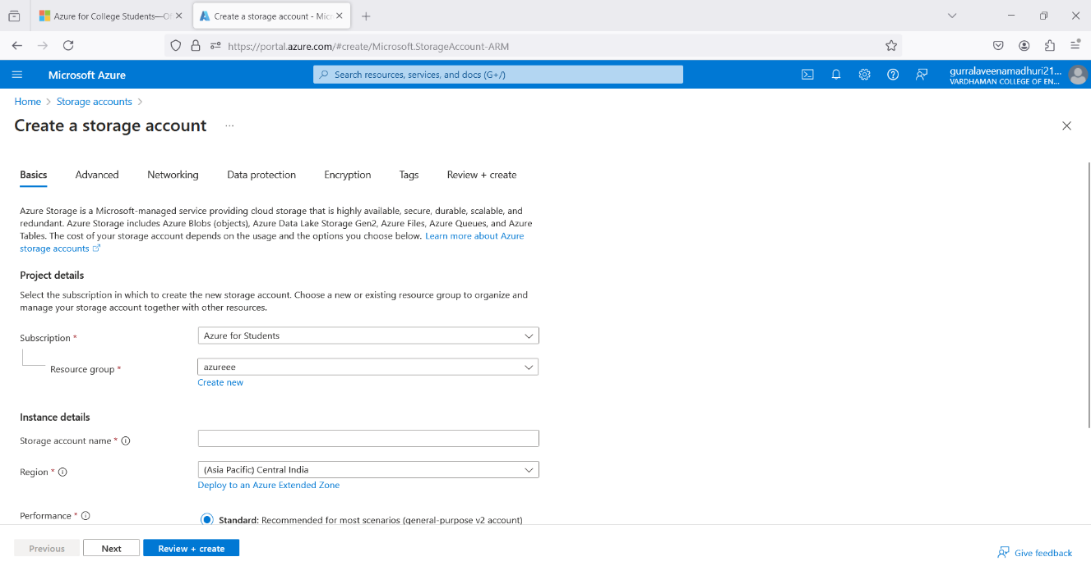

**Step-2:** Go to advance and Allow enabling anonymous access on individual containers.

 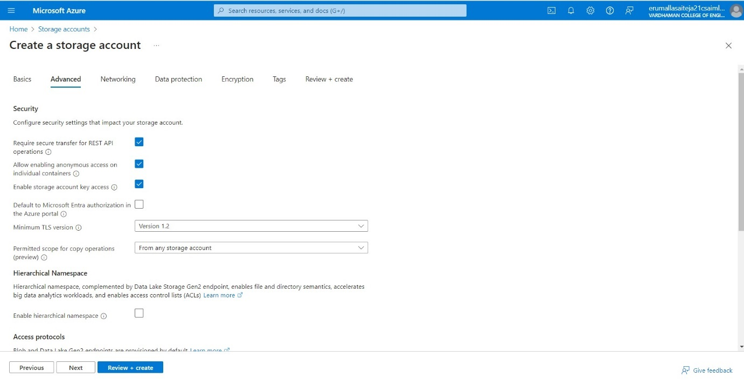

**Step-3:** After deployment Click on go to resource group and on Left Click on Containers and Create it with anonymous access level as blob (anonymous read access to blob only)

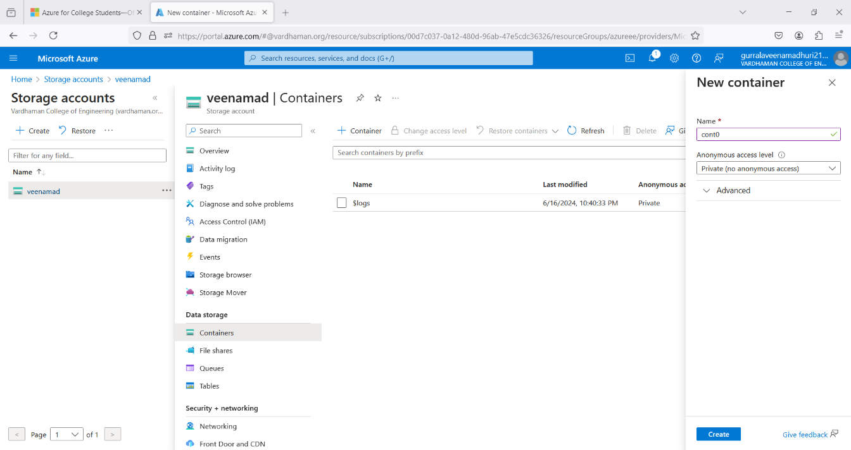

**Step-4:** Then open new container, click on upload and upload a file from desktop. 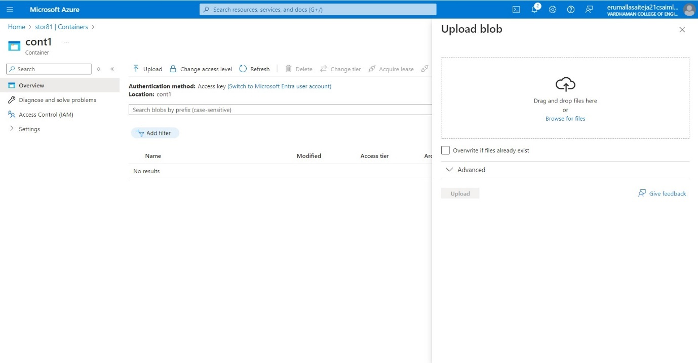

**Step-5:** Select the file and click on provided URL to open the file.

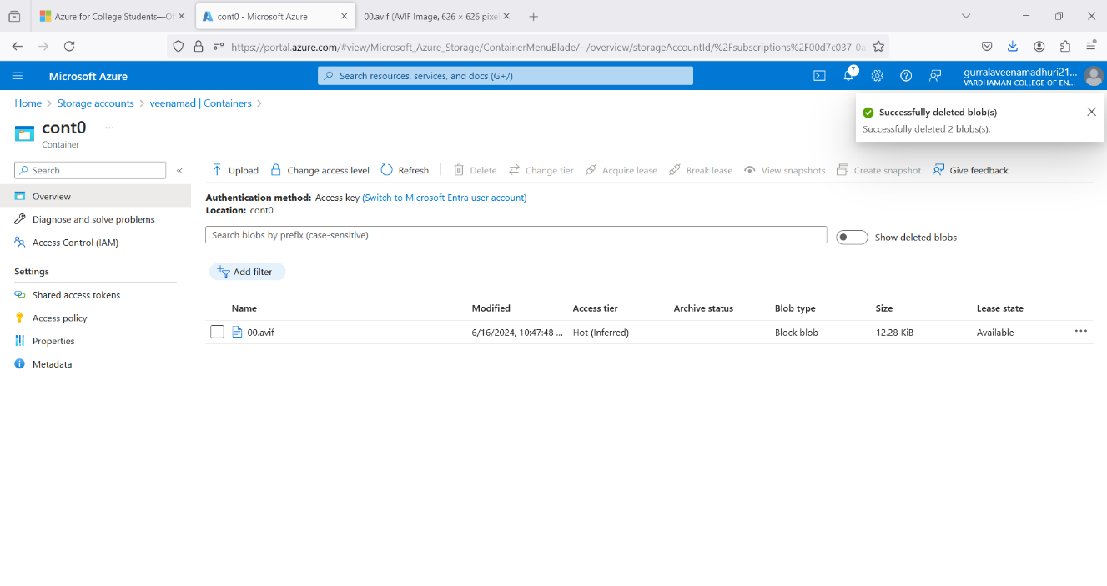

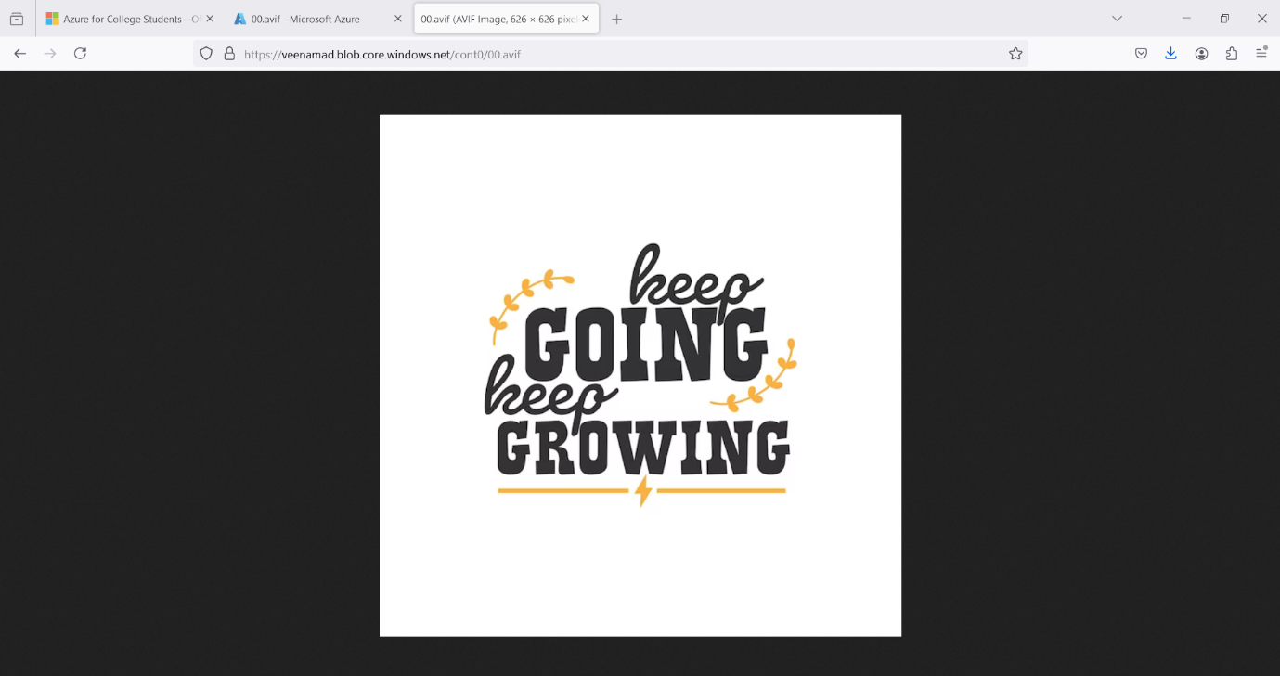

**Step-6:** On container click Change access level to Private (no anonymous access) and try to open the file in new tab it will show error.

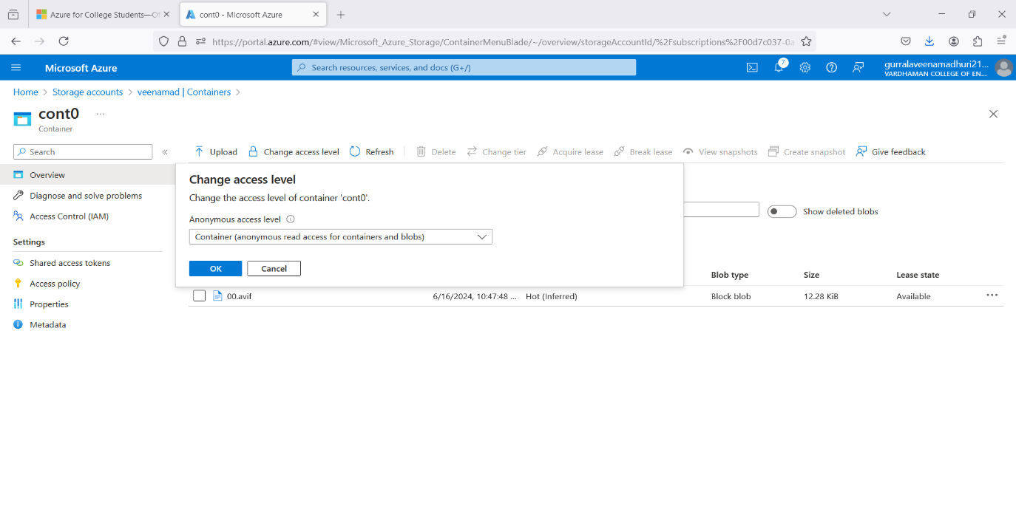

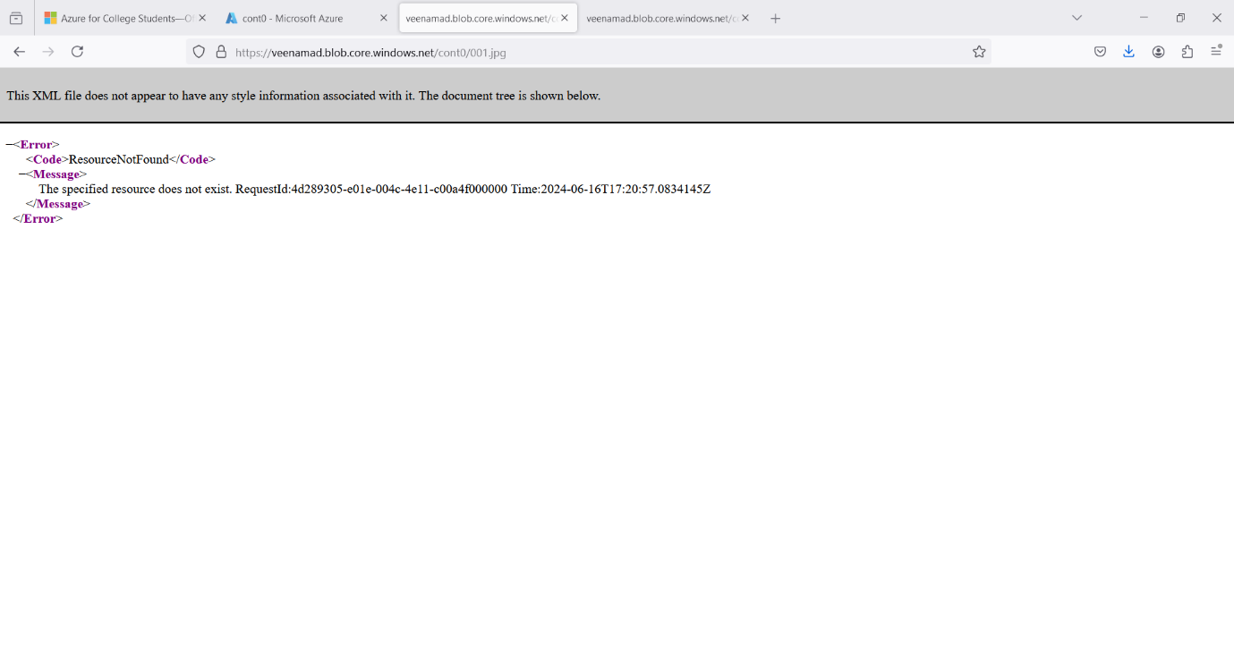

**Step-7:** Then delete blob container and storage account.